ALL LONDON REFERRAL FORM
STRICTLY Private and Confidential

Please tick which organisation/s this referral is for. You can tick more than one:
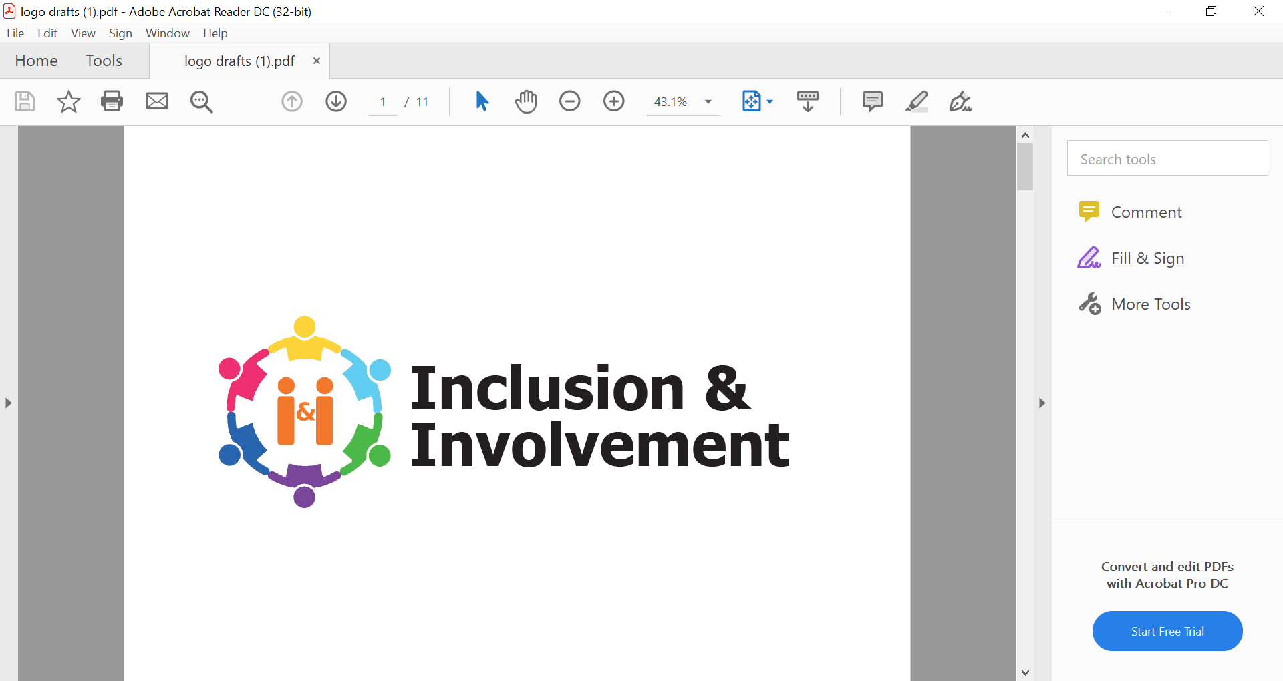
Inclusion and Involvement (I&I) (males only)*

Together for Mental Wellbeing (males only)*



Bluebird – Women in Prison (females only)


Penrose – Housing and Support Services (male and female)**

SWIM – Support service for BME older men


- Please ensure you read the relevant service information sheet before making a referral
- All referrals MUST be screened into the OPD Pathway. If you aren’t sure if the case is screened in, please speak to your local PD Practitioner before completing this referral form
- All referrals need to be signed off by the Probation Practitioner (PP).

* Please complete Annex A of this application for I&I/Together referrals only.
** Please be aware that we will assess people’s suitability at the HASS; however, a positive assessment outcome is not a bed offer. You cannot, at this stage, offer placement in HASS as an accommodation option to the Parole Board. As the Responsible Officer, you will need to check with the Penrose HASS management team 2/3 months prior to the Parole hearing for an update on bed availability, and confirmation that the person you work with can be placed on the waiting list. It is imperative that you have a contingency resettlement plan in place until you have confirmation a bed is available.

SUPPORTING DOCUMENTATION REQUIREMENTS:
Referrals for the Inclusion and Involvement (I&I) Team do not need any additional documentation.
Referrals to all other OPD organisations need:
Level 2 or 3 Formulation with date and author of formulation. This should follow the third sector formulation pro-forma.
NB: A full OASys is not required. However, details of the risk assessment and redacted risk management plan are included in this referral form.

Date of referral: |  |  | LDU:
Person on Probation’s Details
Name |  |  | Date of Birth
Telephone number |  |  | CRN
Address

Ethnicity
Sexuality
Any known neurodiversity
Learning Difficulties/Needs
Release date
Supervision end date: |  | Is this person expected to be managed post licence? Yes /No

Referrer (Probation Practitioner) Details.
If another professional instigates this referral, it must be signed off and agreed with the PP.
Name
Job Title
LDU address
PP telephone number
PP email
Name of SPO
SPO telephone number
SPO email

Emergency contact details
In case of emergency, please provide details below. Please add further boxes if required.
Next of kin:  Name: | Nature of relationship: | Contact Tel: | Email Address:
GP:  Name: | Name of surgery: | Contact Tel: | Email Address:
Other:  Name: | Nature of relationship: | Contact Tel: | Email Address:

Motivation and Protective Factors
Please comment on the person’s reason for wanting to work with the relevant organisation and their motivation to live an offence free life. Please also mention any work that the client has done this far to reduce risk - indicating their key areas of support and priorities.
Is the person on probation aware they screen into OPD Pathways? |  |  | Yes No
Has the referral been discussed as part of consultation and identified as part of the person on probation’s Pathway Plan? |  |  | Yes No
Has this referral been discussed with the person on probation? |  |  | Yes No
MAPPA Level: |  |  | NA / 1 / 2 / 3
What is the Pathway plan and person on probation’s goals? | 1.  2.  3.
Please provide details of Personality Disorder diagnosis/traits
Any mental illness? | Yes /No | If yes, please give details:
Current Medication? | Yes /No | If yes, please give details:
Any disabilities? | Yes /No | If yes, please give details:
Any substance misuse? | Yes /No | If yes, please give details:

Risk Assessment
Risk to self: Yes: No: | Risk to others  Children  Low: Medium: High: Very High:  Risk to Public  Low: Medium: High: Very High:  Risk to Known Adult  Low: Medium: High: Very High:  Risk to Staff  Low: Medium: High: Very High:  Risk to Prisoners  Low: Medium: High: Very High:
Please provide details from OASys, using the headings below. Please include assessment of risk to self where relevant:

Nature of risk

Signs of increased risk and when is risk likely to be greatest

What circumstances are likely to increase risk

What factors are likely to reduce risk

Risk Management Plan (RMP)

Please cut and paste from OASys - redact where necessary (e.g. do not include victim details).
Please include contact details of any practitioners/ agencies/ workers involved in the referral process

Summary of Identified Needs
Please rate the following level of need with 0 = no need, 1 = need
Accommodation |  | Alcohol misuse
Education, training and employment |  | Emotional wellbeing
Finances |  | Thinking and behaviour
Lifestyle and associates |  | Attitudes
Drug misuse |  | Health

Please send referrals to:

Involvement and Inclusion (I&I): oxl-tr.sui-si@nhs.net

Together: together.referrals.twp@nhs.net

Women in Prison: london.referrals@wip.cjsm.net

Penrose: Women: referrals.hsh@penrose.cjsm.net
Men: opdhass.referrals@penrose.cjsm.net

SWIM: louise.merrifield@swim.cjsm.net; Peter.merrifield@swim.cjsm.net

PP Signature:

Annex A

INCLUSION & INVOLVEMENT (I&I) ONLY
Which services are the person interested in?

Young Adult Outreach Service – 18-30 yrs old (Newham and Brent Only)
Support with emotional wellbeing/socialisation (Hub based)
Transitional/practical support - housing, finance, ETE, health (Hub based)
Volunteering at the Hub
- Reception, Café, Delivery
Support group spaces
- Black Levity, Sexuality Support Space, Substance Use Support Group
Being Heard Pathway
- The Forum, Involvement Days
Service User Involvement
- Training, recruitment, consultation, research, group facilitation, marketing & comms
Supported Work Placement with the Quakers
– Bake the Difference, Maintain the Difference, Redemption Roasters

Please note: I&I is not a therapy service nor a service to provide monitoring and supervision of a service user’s lifestyle. It is a service that works alongside other interventions.

TOGETHER ONLY
Which services are the person interested in?
Emotional and practical support
Wellbeing groups*
Peer Support – one to one and group support*
* Together does not accept referrals yet for this offer – they will advise as soon as this is available.
Please provide additional client information below:
NOMIS number |  | PNC Number

INCLUSION & INVOLVEMENT (I&I) AND TOGETHER REFERRALS ONLY:

Approval of Hub attendance
The Hub is held in a closed space in the Seed Kitchen area of Friends House, 173 – 177 Euston Road, London NW1 2BJ.

Please tick to confirm:

☐ Does not breach exclusion zones

☐ Is allowed to access IT / internet

☐ Is allowed to attend all activities

☐ While the hub area is a closed space, the main building is open to members of the public of all ages. Please confirm this is ok.

☐ There will be a mix of offending histories. Please confirm that the person you are referring will be able to 1) not discuss offending histories, 2) are risk assessed as able to manage being with people who may have committed any offence.

☐ If you have not approved any of the above conditions, please give further details and indicate any measures that would enable the team to safely engage the person.

☐ I confirm the person is suitable to attend the Hub space

PP Signature:

