

**Mental Health Self-help Guide**

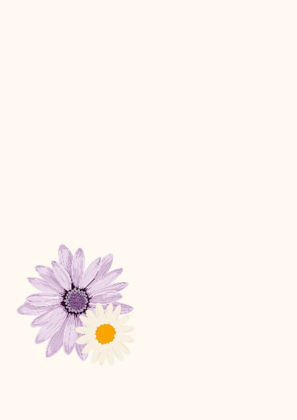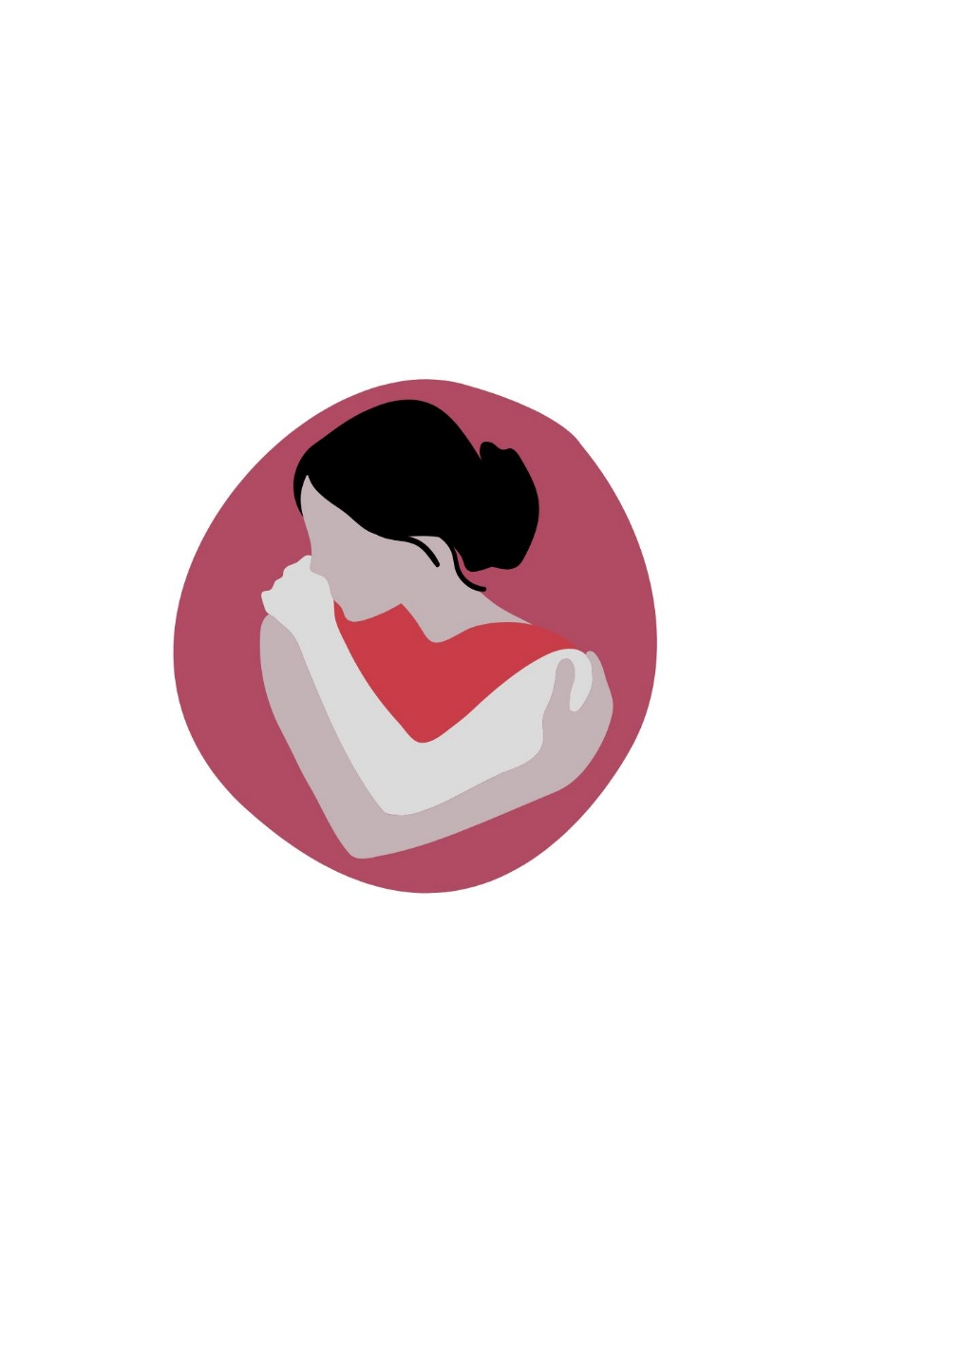







**Shama Women’s Centre**

**39-45 Sparkenhoe Street**

**Leicester, LE2 0TD**

**Tel: 0116 251 4747**

[**www.shamawomenscentre.co.uk**](http://www.shamawomenscentre.co.uk)

**Email: info@shamawomenscentre.co.uk**

**OPENING HOURS**

**Monday 9.00am - 4.45pm**

**Tuesday 9.00am - 4.00pm**

**Wednesday 9.00am - 4.45pm**

**Thursday 9.00am - 4.00pm**

**Friday 9.00am - 4.45pm**

**Saturday & Sunday closed**



Registered Charity - No - 1087995

**Useful Numbers**

**For Counselling and well-being services.**

**Shama Women’s Centre: 0116 251 4747**

If you are experiencing distress and feel that you are at risk from harming yourself, please call 999.

If you feel distressed and would like to talk to someone

immediately please call:

Leicestershire Mental Health Crisis Support: 0808 800 3302

Anxiety UK: 03444 775 774 Text support 07537 416 905

Samaritans 116 123

**For self – harm**

Harmless

Email: [infor@harmless.org.uk](mailto:infor@harmless.org.uk)

Website: [www.harmless.org.uk](http://www.harmless.org.uk)

NHSN (National Self Harm Network)

Website: [www.nshn.co.uk](http://www.nshn.co.uk)

**Bereavement**

Bereavement Advice Centre

Tel: 08000 634 9494

Website: [www.bereavementadvice.org](http://www.bereavementadvice.org)

CRUSE Bereavement Support

<Tel:0808> 808 1677 Website: www.cruse.org.uk

2

2

**Introduction**

This is a self-help guide for those who are experiencing mental health problems and bereavement.

This guide is to give you understanding of what you may be going through and tips on how you can help yourself while going through these life challenges.

When you are going through trauma, mental health challenges or bereavement it can have an impact on your life and you may feel stuck or helpless.

This guide is to show you that there is help out there and having an understanding of what you are going through will help you understand your process and get the right help you need.

Everyone’s mental health challenges and their bereavement journey is different, and people have different experiences of these problems. This guide has been designed to help you identify how your mental health challenges and bereavement journey has affected you and begin to work on your behaviours by self- reflection and understand your thoughts and feelings that are keeping you from the life you want to lead.

3

**Contents**

Most Common Mental Health Disorders Pg. 5

What is Anxiety? Pg. 6-12

What is Depression? Pg. 13-17

What is a Panic Disorder? Pg. 18-23

What is Social Anxiety Disorder? Pg. 24-26

What is Obsessive Compulsive Disorder (OCD?) Pg. 27-32

What is Post-Traumatic Disorder (PTSD)? Pg. 33-35

What is Self-harm? Pg.36- 39

Bereavement Pg. 40-43

Where can I get more help? Pg. 44

4

4

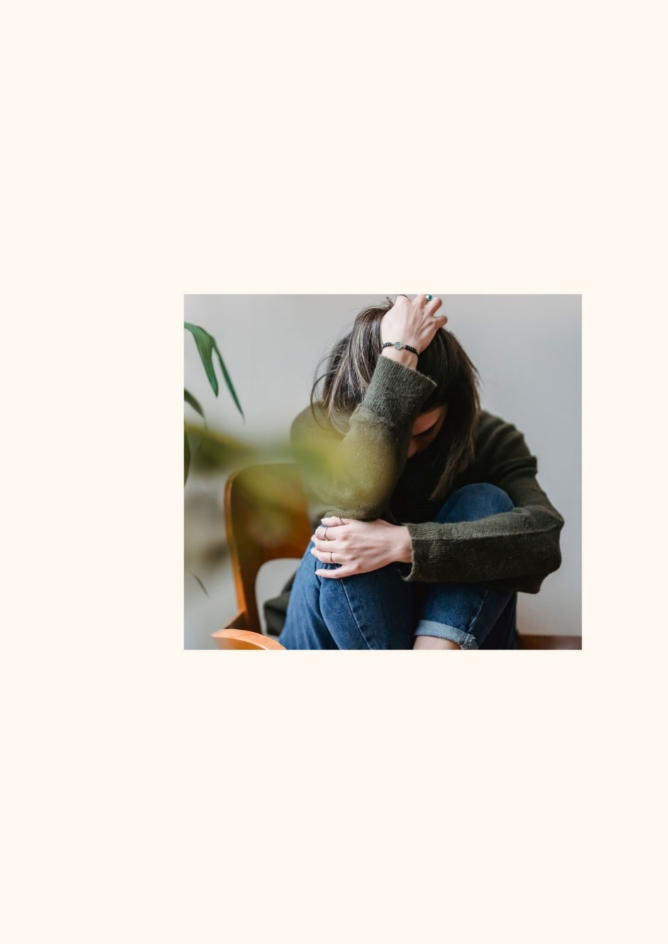

**Most common mental health disorders:**

Anxiety

Depression

Panic Disorder

Social Anxiety Disorder

Obsessive-compulsive disorder (OCD)

Post-Traumatic Disorder (PTSD)

5

5

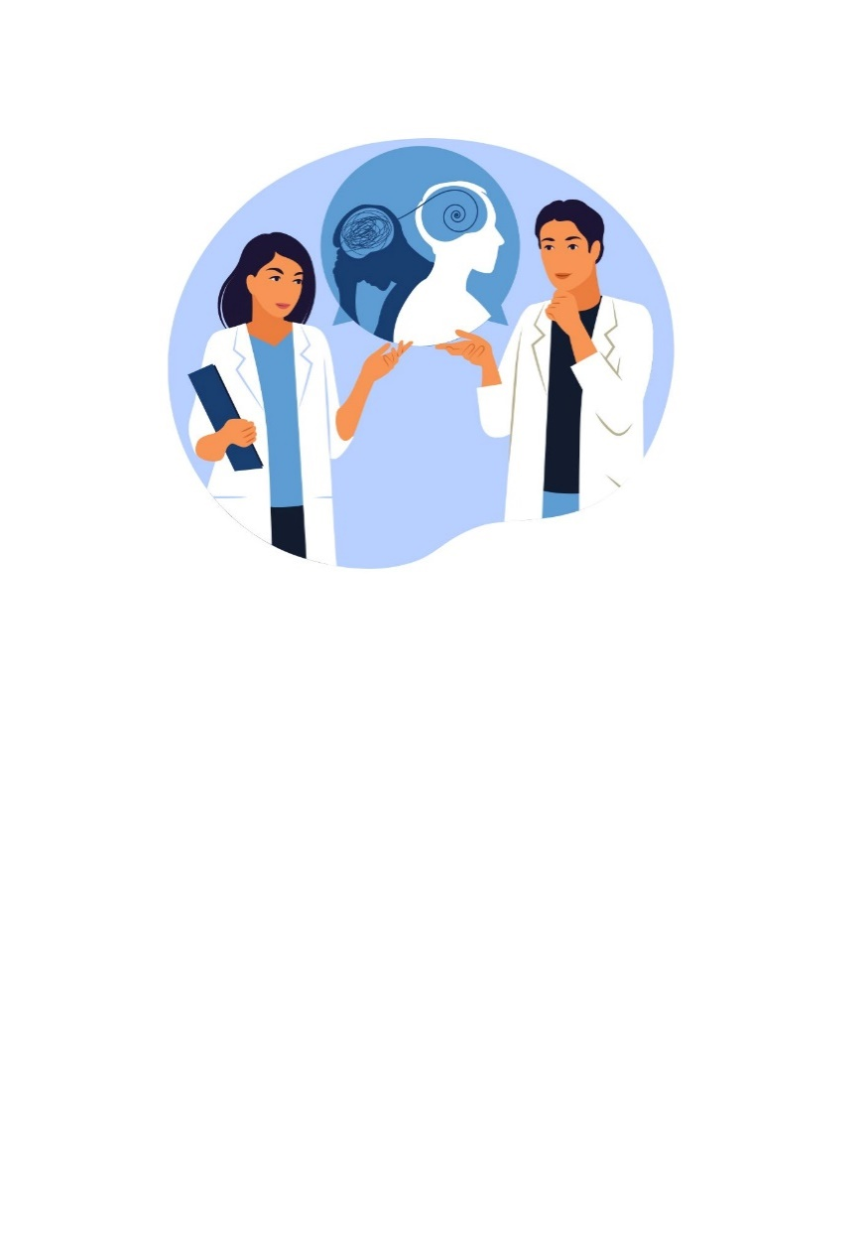

**What is Anxiety?**

Anxiety is a feeling we experience when our body is dealing with unease, worry and fear.

Anxiety can be mild or severe, it varies from person to person.

It means your body is getting ready to do something. This could mean it is getting ready to protect yourself by fighting the danger or running away from it also known as fight or flight response.

Anxiety is like an alarm that goes off in the body to let you know there is danger.

6

6

**SELF**

**CARE**

**ISN’T**

**SELFISH**



**How Anxiety might make you feel**

Everybody experiences anxiety in a different way. It has the power to alter your mood. Your thoughts, your actions, and your physical state.

Below are some symptoms when experiencing anxiety:

* Dizziness.
* Palpitations.
* Trouble breathing.
* Muscle pain.
* Numbness.
* Pins and needles.
* Nervousness.
* Stressed.
* Think the worst will happen.
* You think you are going to die.
* Not being able to concentrate.

7

7

You may also start to act differently. You may walk up and down a lot, you cannot relax, you are angry at people, your appetite may increase or decrease, and you may smoke or drink more.

You may want to be left alone and others may need someone to be with them.

8

8

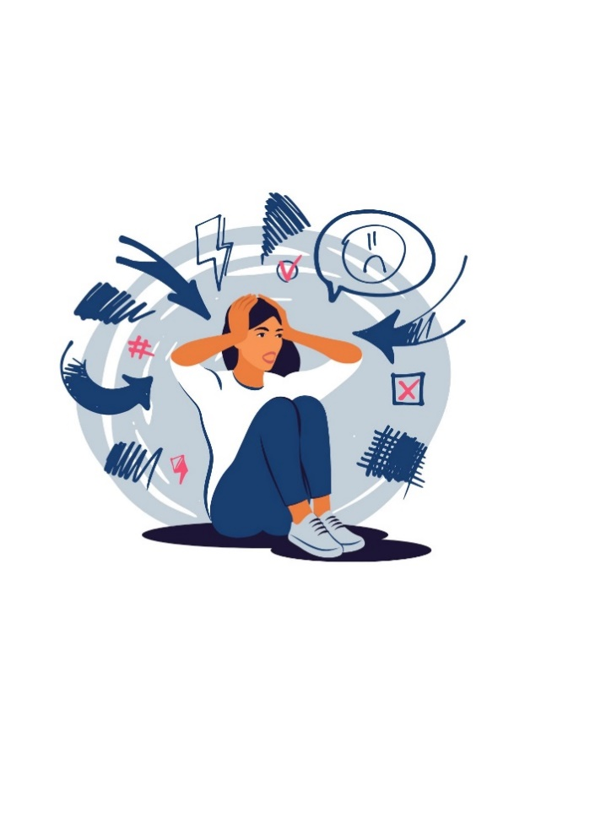

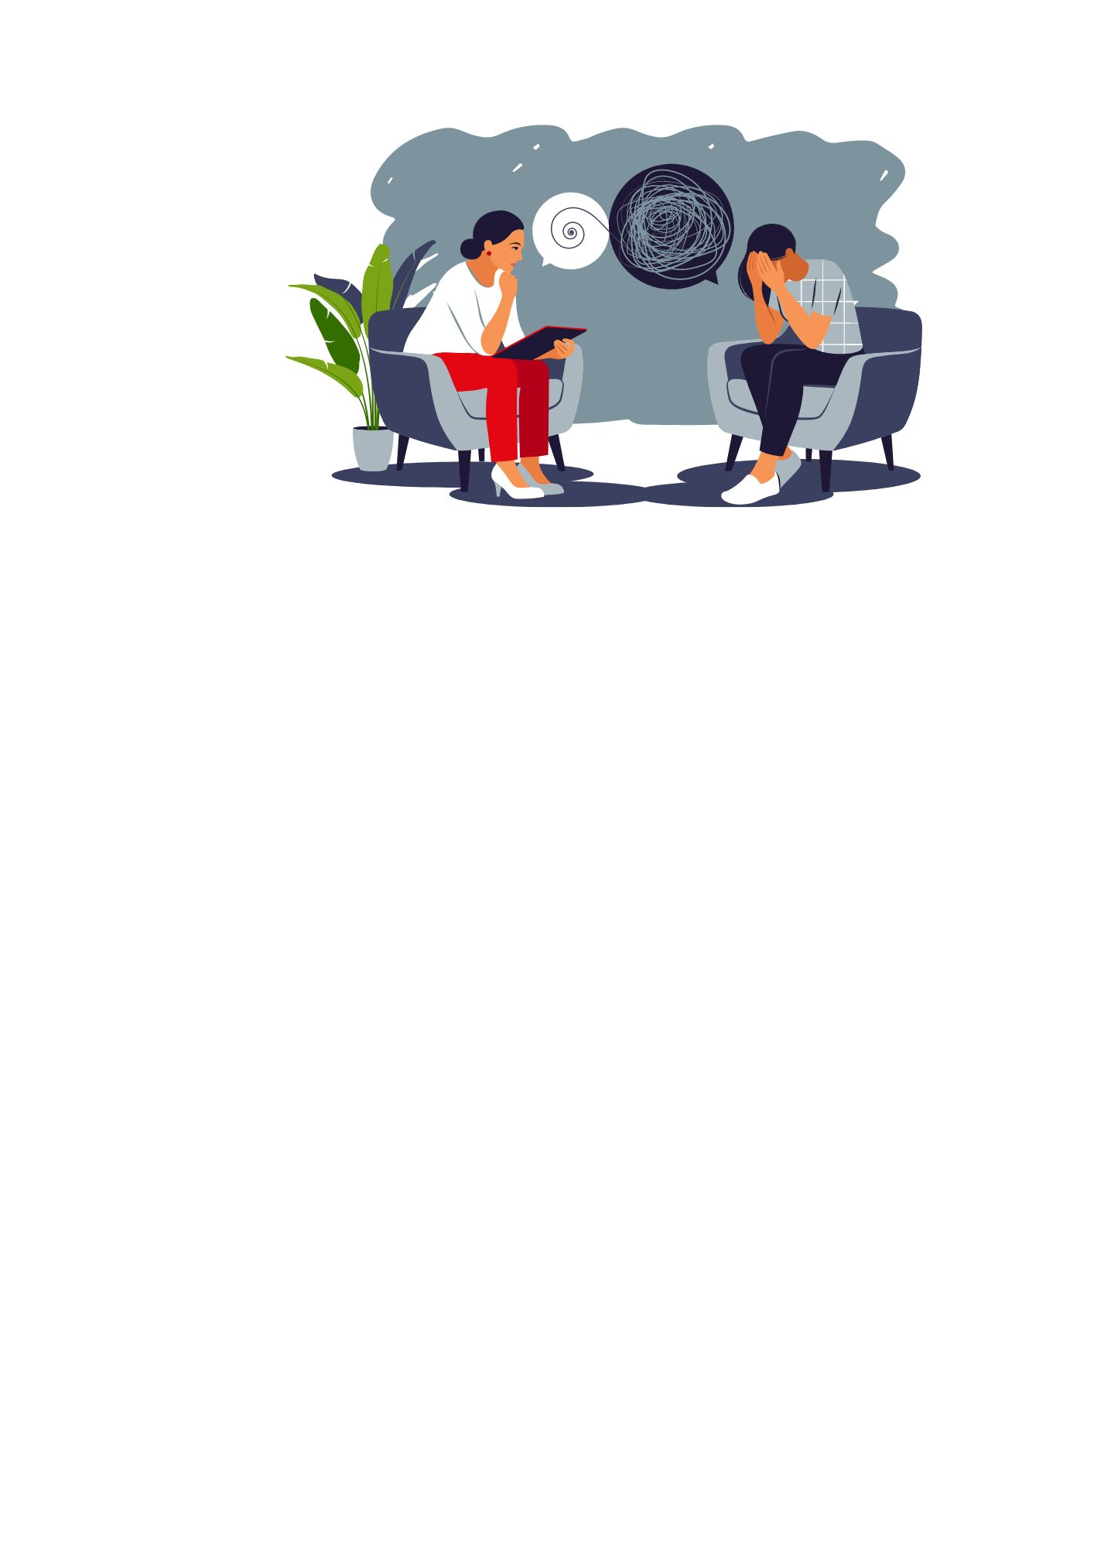

**Things you can do to help with Anxiety.**

Anxiety can get better. First you need to find out what is causing the anxiety.

It can help if you think about the things that make you nervous or scared. Has there been any significant event taken place in your life?

Thinking about these things may help you see what is causing your anxiety, sometimes having the awareness can help reduce your anxiety.

Seeing a therapist/counsellor can help you talk through your feelings and thoughts or seeing your GP.

9

9

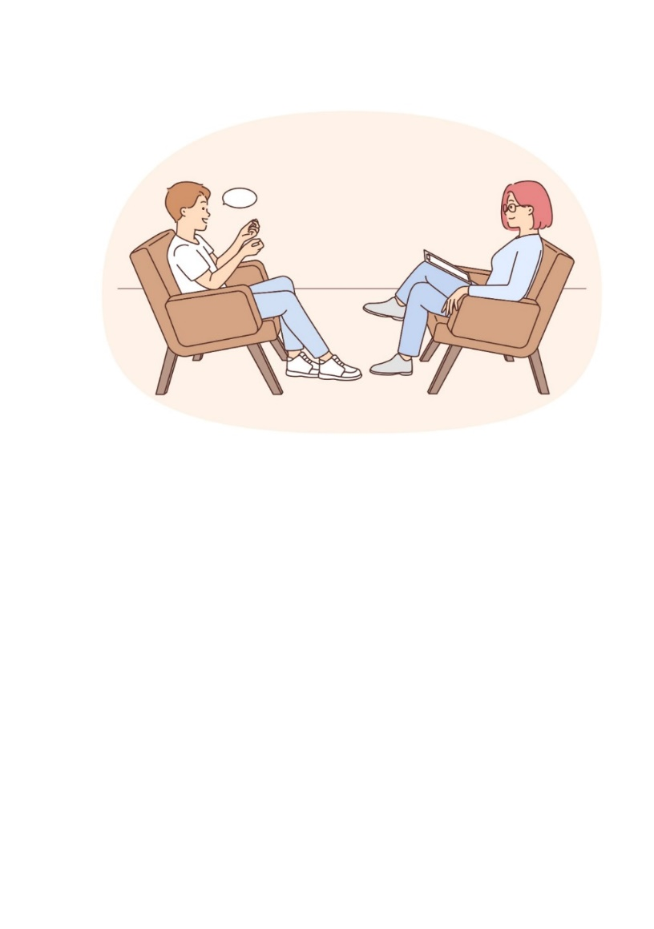

Listening to your favourite music or some upbeat lively music can help reduce your anxiety.

Studies have shown movement of the body whether dancing or exercise helps to relief stress by increasing the “happy hormone” (dopamine).

Also, movement helps the body shake off the stuck emotions that have been stored in your body and shaking the body helps move them and release them from your body.

Journaling is a good way to keep track of your thoughts and feelings and it also gives you a sense of unloading instead of carrying your thoughts and feelings with you.

10

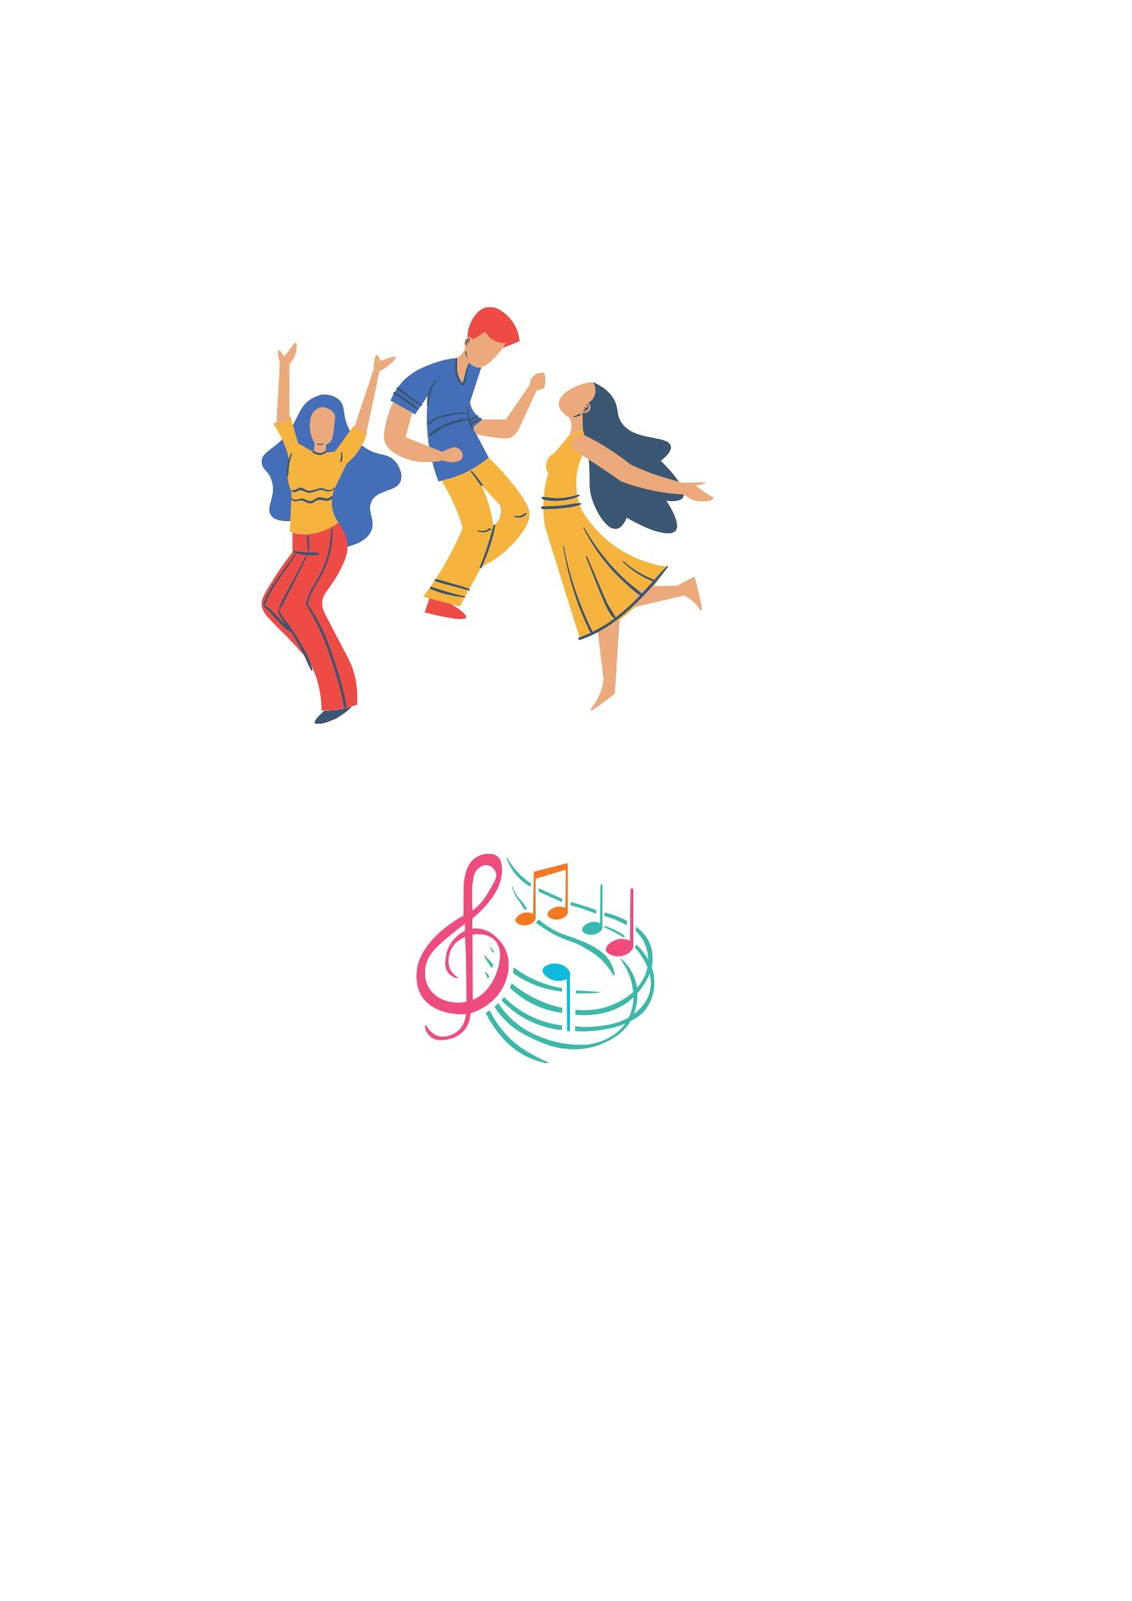

Fees Applicable



Daily breathing exercises, meditation and mindfulness is also a great way to help reduce anxiety.

There are many YouTube videos available on breathing exercises and meditation that can help. Have a look and see which one suits you.

Avoid breathing too rapidly as this could aggravate your symptoms. Breathe deeply and slowly until the anxiety begins to subside.

11





**Changing the way, you think.**

It can be difficult to change your thought process when you are feeling anxious. Sometimes this makes the anxiety worse.

It is important to recognise the negative thinking pattern that makes your anxiety worse.

Try and think about the good things you have done or happened in the last week or days. Try and shift your focus onto the more positive thinking patterns and this will help reduce and manage your anxiety.

Sometimes bad life experiences can give you anxiety and it important when that happens you seek help through your GP who can guide you to the right help.

You can also self-refer yourself for counselling at many organisations like Shama Women’s Centre to help with your anxiety.

12



**What is Depression?**

Depression is a mood disorder that causes continuing feelings of sadness and loss of interest. Depression and low moods are a very common problem. It can happen because of having a lot of worries and fears.

Money, housing, relationships, jobs, health concerns, losing someone or something close to you, or when someone you love passes away are some of the things that people worry or fear about.

These anxieties and fears can occasionally cause disruptions in day-to-day activities.

Some people might eventually feel fine again, but others might struggle and require assistance.

13

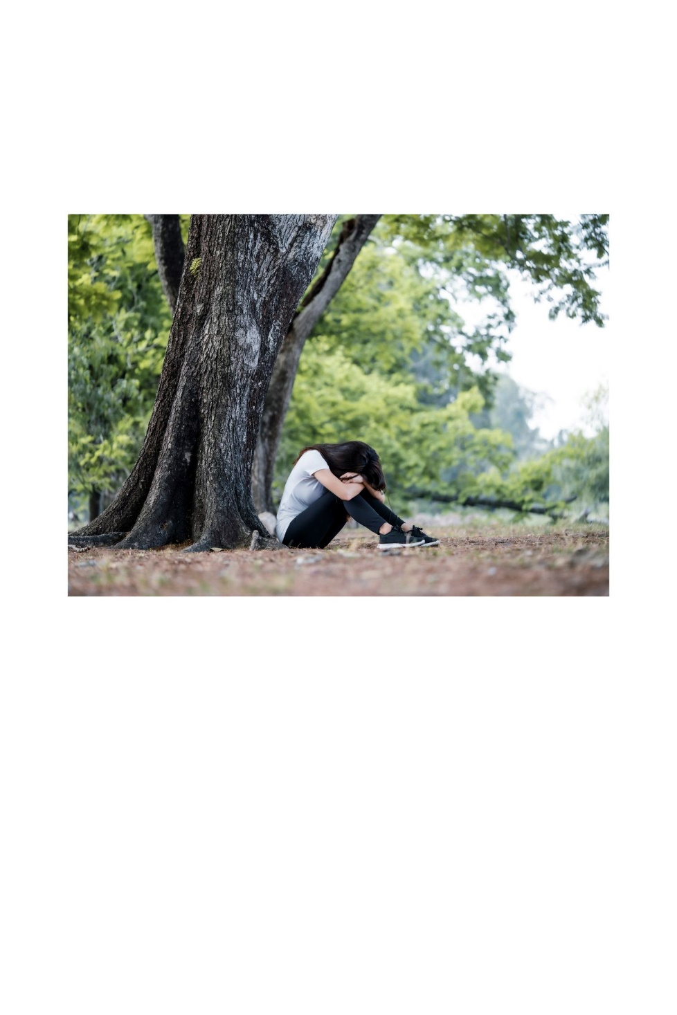

**What we know about Depression.**

People can become depressed when things in life become difficult.

People who are depressed have bad thoughts about themselves, low self-esteem and low confidence.

The way you think about yourself is very important and changing the way you think will help you with depression.

**Having Negative Thoughts.**

We all experience negative thoughts and feelings. This can occur with life experiences. Generally, these negative thoughts and feelings won’t last long.

When you are depressed these negative thoughts and feelings don’t go away and can be very persistence in every aspect of your life.

14

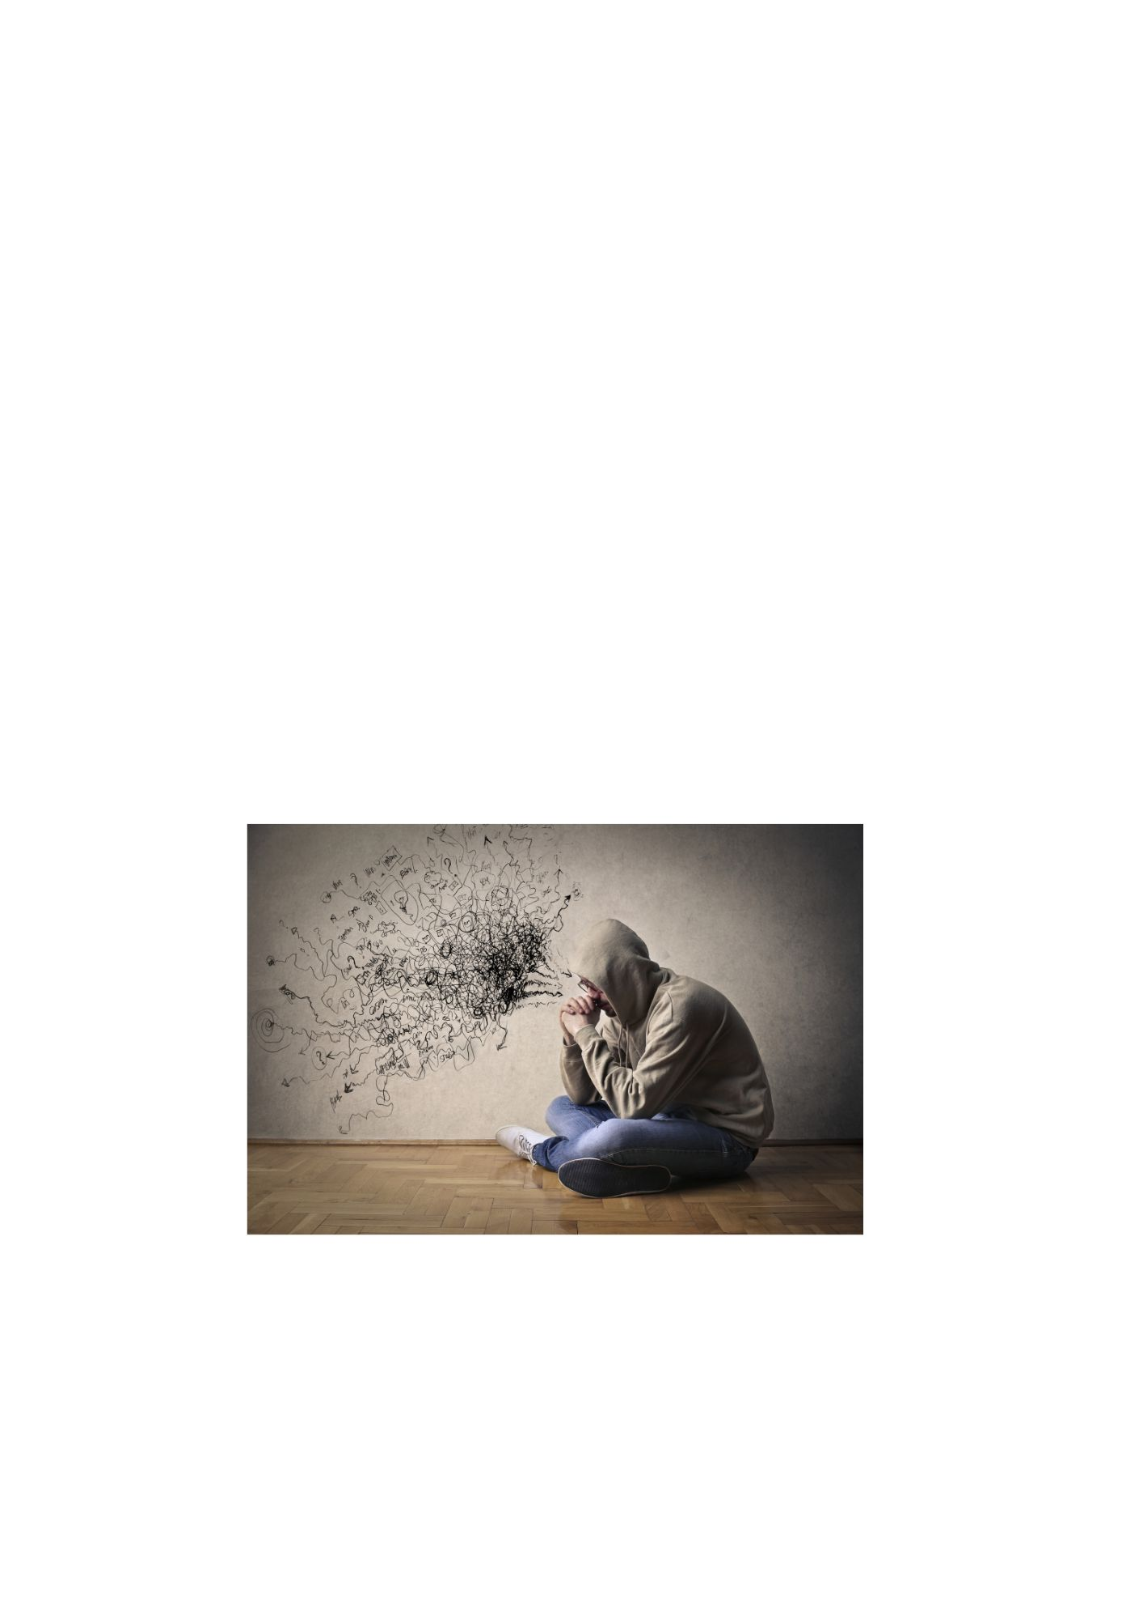

**Things you might feel when depressed.**

* Feeling sad, guilty, upset, or hopeless
* Losing interest in things you once found enjoyable.
* Crying.
* Finding it hard sometimes to cry when something has happened.
* You feel alone or lonely.
* Feeling angry, frustrated and get irritable at the smallest things.
* Feeling tired wanting to sleep a lot.
* Having problems sleeping or staying asleep.
* Changes in weight loss or increase in appetite.
* Losing confidence in yourself.
* Hating yourself.
* Not being able to concentrate.
* Forget things.

15

* Thinking about harming yourself (SPEAK TO SOMEONE STRAIGHT AWAY IF YOU FEEL THIS WAY)
* Expecting the worst to happen.
* Having sad thoughts.
* Can’t be bothered to do anything.
* Putting off things, you need to do.
* Find it difficult to make any decisions.

If you feel you are suffering from depression it is important to get the help you need to feel better.

You can contact your local GP or in this booklet there are several organisations that may be helpful.

You can also go for counselling/ therapy where you can talk about how you are feeling.

16

15

**You can also help yourself by:**

* Planning out your day and tasks that you need to do so that you don’t feel overwhelmed.
* Meeting with friends or family.
* Doing activities.
* Doing some exercise.
* Taking a walk-in nature.
* Doing some hobbies.

17

16

**What is a Panic Disorder?**

Panic is a severe form of anxiety. Panic attacks are a type of fear response. It happens when something you are not expecting takes place and when you don’t know what to do.

You have general panic like if you have lost something like your house or car keys or you have taken a wrong turn.

When you experience a panic attack the feelings are a lot stronger. Panic attacks can affect your body and mind.

Sometimes you can have panic attacks without any cause or reason it just happens.

As the feelings are unexpected and strong it can be frightening.

You often feel the worst will happen when you have a panic attack.

18

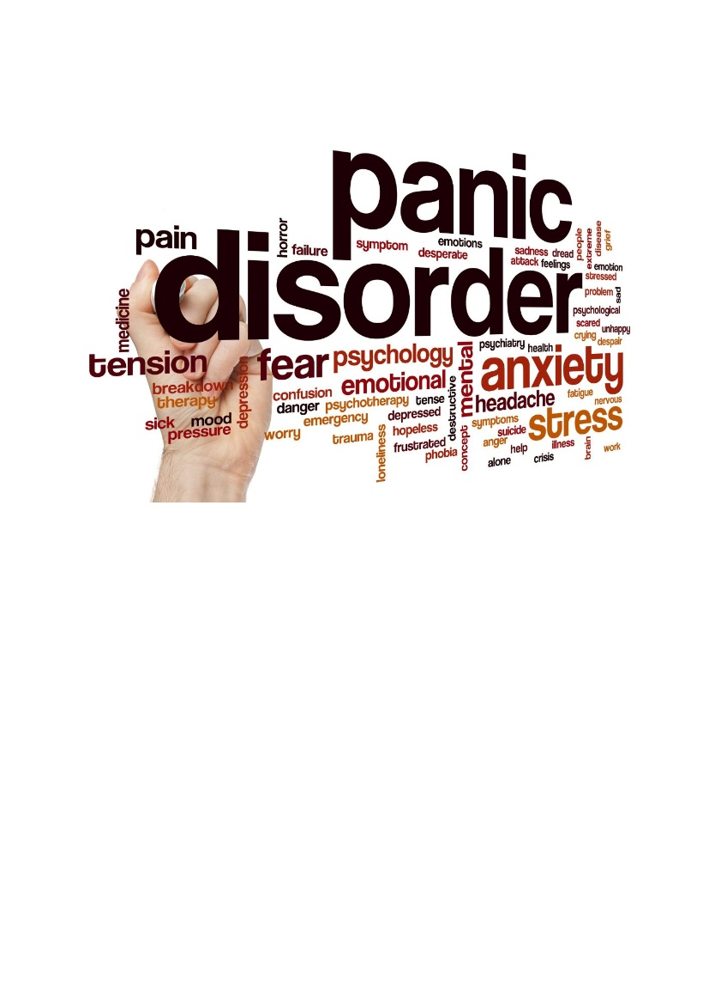

**Things to remember when having a**

**Panic Attack**

* Panic attacks are not dangerous.
* Nothing awful is going to happen.
* Because you experience panic attacks doesn’t mean you are physically or medically ill.

19



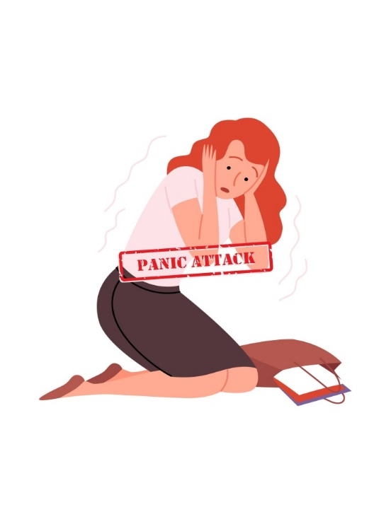

**Some things you may feel when having a panic attack.**

* Sweating.
* Trembling.
* Shaking.
* Numbness.
* Pins and needles.
* Trouble breathing.
* Chest pain.
* Muscle pain.
* Feel frozen.
* Feel a lump in your throat.
* Nausea.
* Feeling like you are going to faint.
* Feeling that you may die.
* Feeling suffocated.
* A need to get away or run away.
* Headaches.
* Palpitations.
* Disorientated.
* Scared.

If you feel you may have panic disorder it is important to get the help you need.

You can contact GP or in this booklet there are several organisations that may be helpful.

20

**Why do people get Panic Attacks?**

When you are having a panic attack you are feeling fearful, and this can happen when you are very scared.

Fear is an emotion you feel that helps you keep safe when you are in danger.

The problems with panic attacks are that you are feeling fearful even when there is nothing to be scared of.

**What can trigger a panic attack?**

* Stress.
* Being unwell (illness).
* Painful or bad memory.
* Negative flashbacks.
* Sometimes there is no reason.

21

**What fuels Panic Attacks?**

People who experience panic attacks are not sure what is going on. This can make them feel more panicky.

Your thoughts can make you panic. Thinking about your triggers or being in a place where you previously had a panic attack.

By avoiding certain things, feelings, or thoughts that you feel may cause you to panic, you end up staying in the same cycle of fearfulness.

Staying in that cycle you will never learn that panic attacks are not dangerous.

22

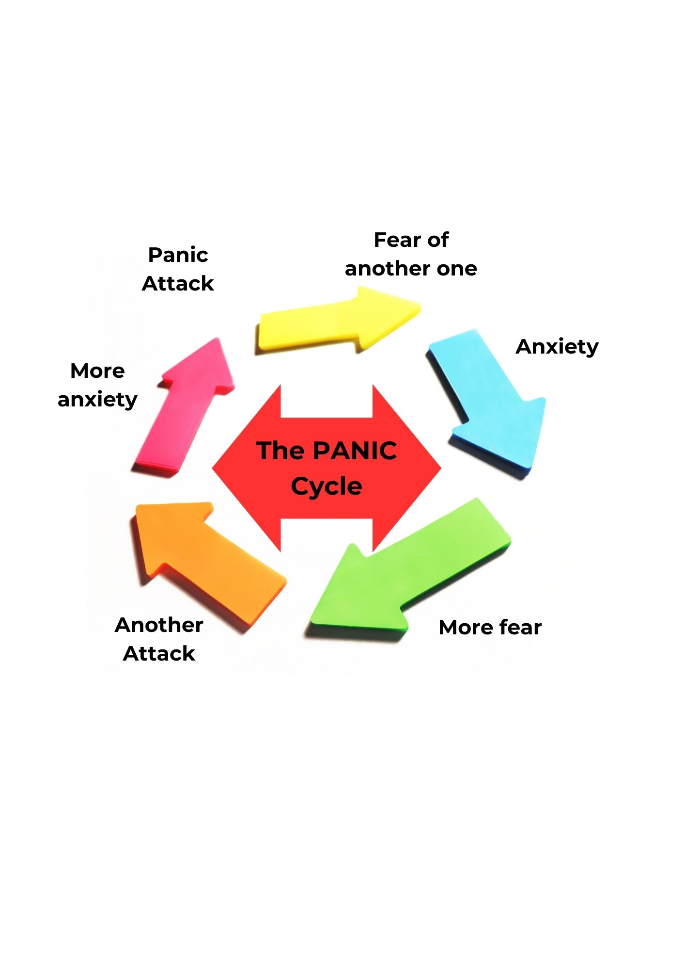

**Things that can help you when you have Panic Attacks.**

* Speak to your GP or if you have a support worker.
* Slow breathing exercises.
* Distract yourself by more positive thoughts.
* Journaling your feelings.
* Educating yourself on panic attacks. This can help you understand yourself better.

23

**What is Social Anxiety?**

An intense fear of social settings, such as meeting or conversing with people, is known as social anxiety disorder.

You're always afraid of doing something you believe looks bad, like blushing, perspiring, or seeming foolish. You find it challenging to complete tasks in front of people; you could constantly feel as though someone is observing and judging you. You avoid making eye contact, fear criticism, or lack confidence in oneself.

24

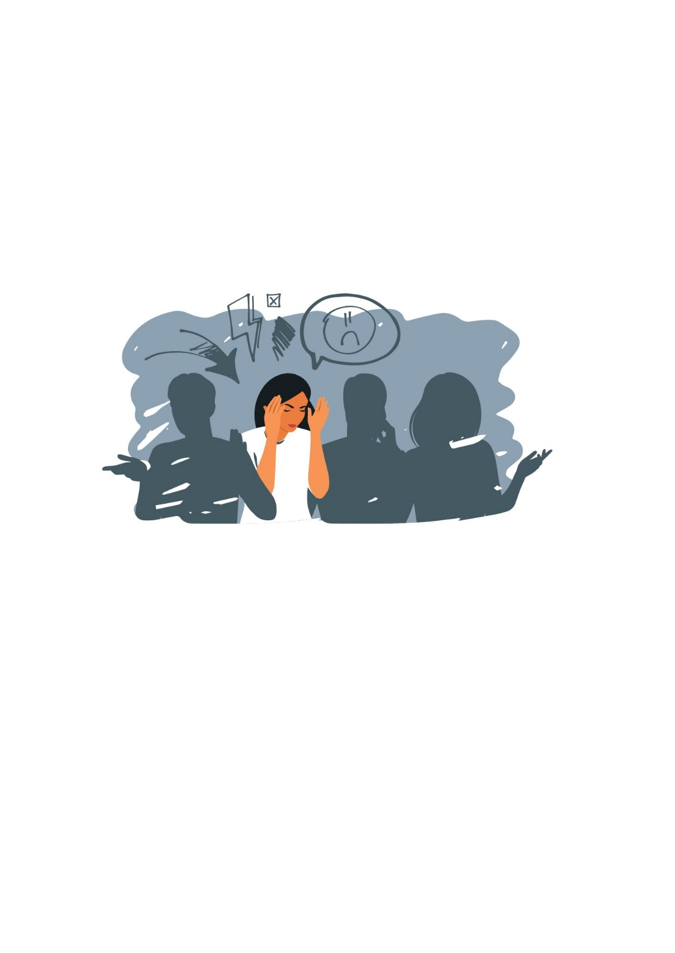

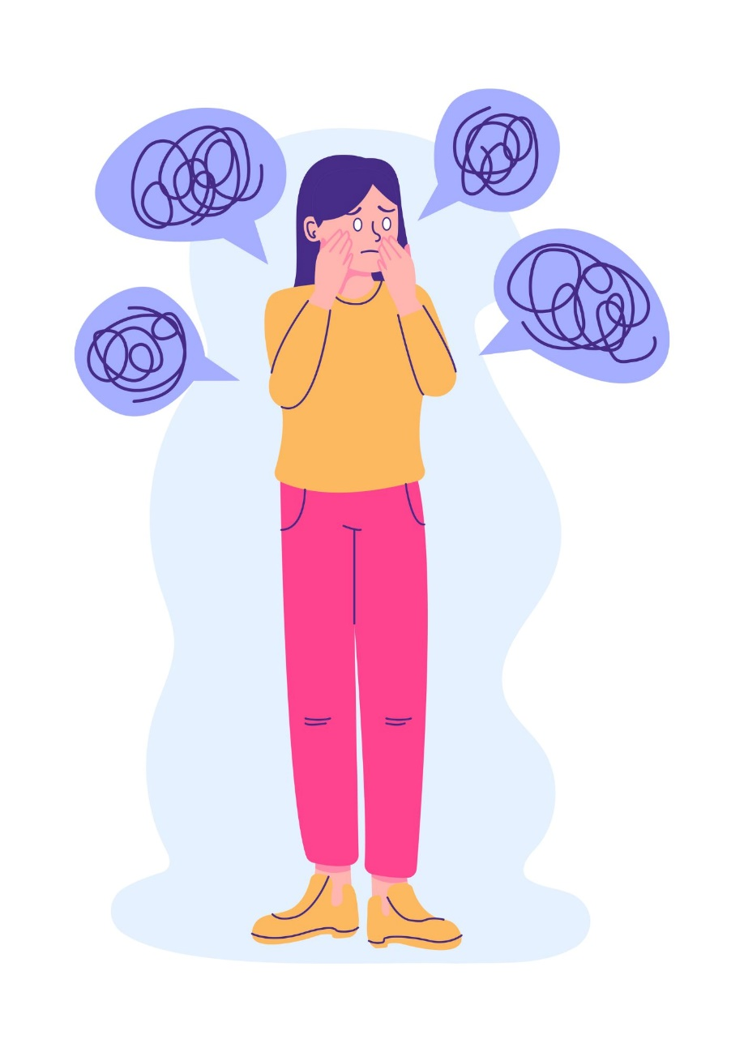

**What you may feel when having Social Anxiety.**

Symptoms you may feel:

* Palpitations.
* Difficulty breathing.
* Numbness in your hand and feet.
* Feeling butterfly sensation in your stomach.
* Dizziness.
* Nausea.
* Isolating, not wanting to go out or see people.
* You might feel you are unable to relax- feel frustrated and irritable.

25

**Things that can help when having Social Anxiety**

* Try and understand what Social Anxiety is and how it affects you.
* Think about how you feel when feeling shy or nervous.
* When you are feeling shy and nervous notice where you are and who you are with.
* Think about what will make you feel better.

Work through one problem at a time and why you feel the way you do.

You can do this by writing, drawing or however you want to express yourself. This will give you an understanding of yourself and keep you distracted.

When you are out and about and you start to feel shy or nervous try not to think about what you are feeling and try to ground yourself by looking around pointing at things you can see, touch, feel, and smell. This will help to ground yourself.

Finally face your fears. The more you avoid them the more it will grow. Take your time and do small steps at a time. Go places you are familiar with and slowly build up.

26

**What is Obsessive Compulsive Disorder (OCD)?**

A mental health illness known as obsessive compulsive disorder causes uncontrollably recurrent thoughts and repetitive behaviours.

Obsessions are common in OCD sufferers. These are unpleasant feelings and ideas that cause someone to feel uneasy, anxious, or afraid.

The person takes action to improve their own sentiments because of these ideas and emotions. We refer to this as compulsive.

You may take frequent baths or showers or wash your hands a lot because you believe you are dirty or that something bad will happen if you touch something dirty.

The majority of OCD sufferers are aware that their obsessions and compulsives are "over the top," but they are unable to stop them. Some people with OCD can lead happy lives and only require assistance when their obsessions and compulsive behaviours become too much for them.

27

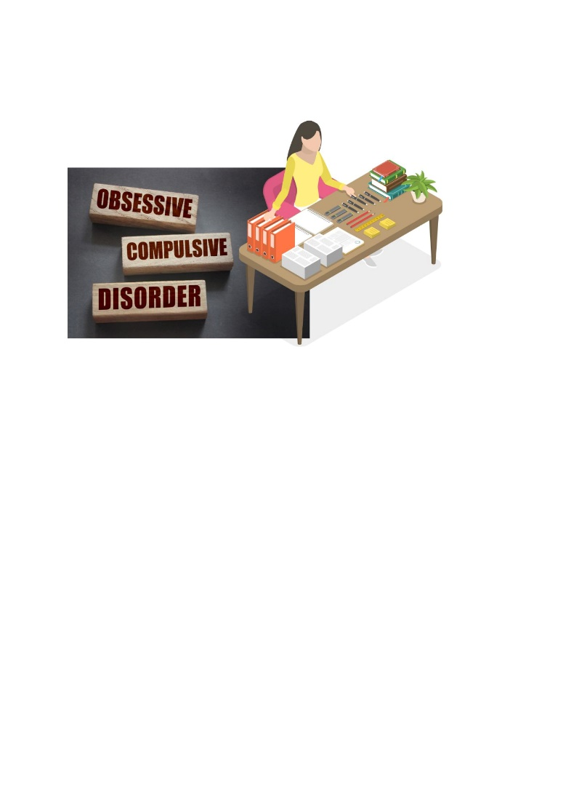

**Regarding OCD, what do we know?**

OCD can affect us in a variety of ways. Everyone is unique. It has the potential to influence how we think, feel, and act.

Some symptoms of OCD include:

* Frightening thoughts, such as believing you are dirty or that bad things will happen if you touch dirty things.
* Thoughts that you will hurt people—for example, you may think you left the cooker on, and it will start a fire.
* Visions of harming other people in your mind.
* Feeling as though there are things in your life out of order, such as your clothes not folded properly or your decorations not being straight.

All of these are obsessions.

28

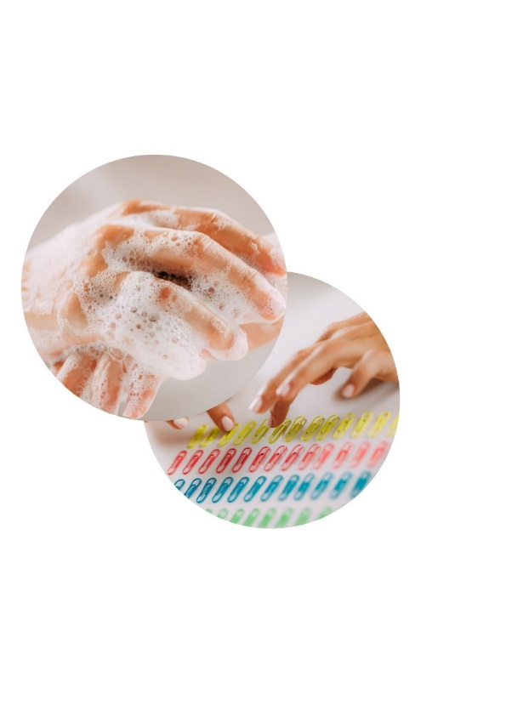

**People with OCD often engage in specific behaviours known as compulsions to help with their obsessions.**

* They frequently wash themselves.
* Avoiding contact with objects that could be contaminated or harbour bacteria.
* Not being the last person to leave the house, or not leaving at all.
* To escape obsessive thoughts, try thinking of different things.
* Rearranging items numerous times until they are "just right".

29

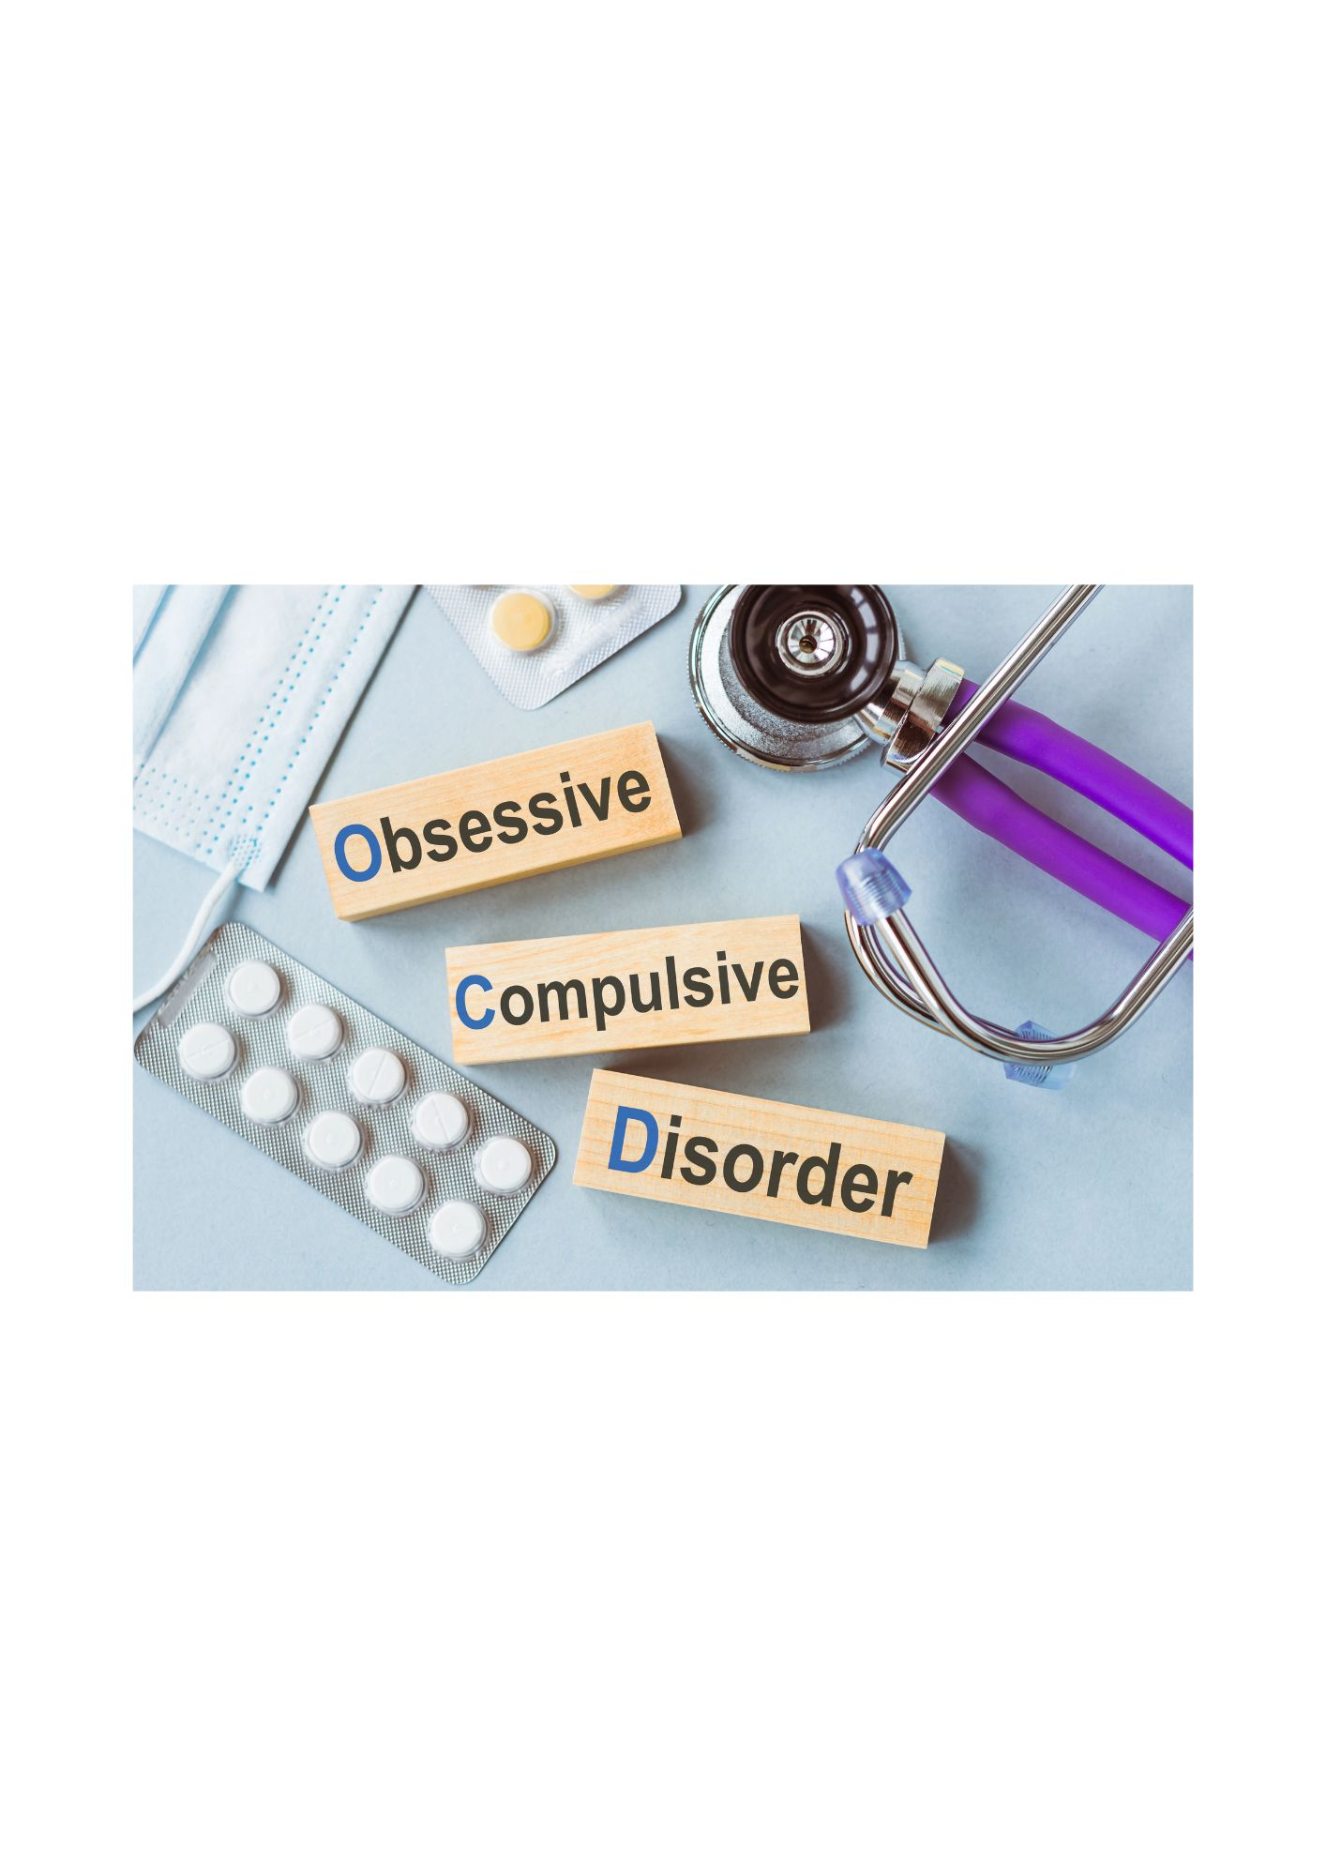

**Is it possible to treat OCD?**

OCD sufferers frequently feel awkward or guilty about having such negative thoughts.

After they've "put things right" with their compulsions, they feel better.

This can make it extremely difficult to stop the thoughts from returning and becoming more powerful.

If you feel you may have OCD you can contact your GP. You could be given medication by your doctor which may take effect in a few weeks or maybe be suggested by your GP to seek counselling to help you understand your thoughts and feelings.

30

**What self-help measures can I take?**

Starting with very small life changes is the best way to help yourself. Next, you can gradually approach the objects that truly terrify you.

Your medical professional can assist you with this.

This story explores how Sam changed her life and put an end to her compulsive thoughts by making small changes.

Sam avoided going outside and spent all her time inside her house because she was so afraid of large groups of people.

Sam's obsession with constantly cleaning her house stemmed from her fear.

In order to overcome her fear of leaving the house, Sam and her healthcare provider devised a plan that began with minor adjustments.

To begin with, Sam and her healthcare provider went for morning walks from her home to halfway down her street for a month. Sam then made her way alone.



31

Sam's healthcare provider and she were to visit the shops at a time when there were fewer people there. Sam spent two months doing this.

Sam felt she didn't always need to clean the more she got out.

Following several months of brief outings, Sam has grown considerably more self-assured and now shops alone.

Sam is free of obsessions and compulsions now.

32



**What is Post Traumatic Stress?**

A very distressing or unexpected event can result in post-traumatic stress disorder.

This could be witnessing someone get hurt, experiencing child abuse, an accident, or the death of a loved one.

This is referred to as trauma at times.

Post-traumatic stress disorder can cause extreme sadness, angst, or upset. Moving forward in life can be challenging.

33



**What you could possibly feel**

Stress related to a traumatic experience can influence your emotions and actions. Each has a unique experience.

A few of the symptoms of PTSD include:

* Anxious, uneasy, or afraid.
* Tense or on edge.
* Angry.
* Depressed.
* Heart palpitations.
* Feeling tired.
* The muscles are sore and taut.
* You might think about what occurred frequently.
* Having difficulty falling asleep.
* You might consume more alcohol or smoke more than usual.
* Certain places might be difficult for you to visit.

While experiencing these emotions after a trauma is common, they should eventually pass.

34

**How can I make myself feel better?**

You have a lot of options for helping yourself move past this experience.

Speak with someone. Discussing what transpired with your family doctor or support worker could be beneficial.

Learn everything you can about the incident. It's sometimes possible to feel better about what happened to you.

Recalling the events with composure can be beneficial. Take some quiet time every day to reflect on what has happened to you. This can assist you in gaining control over your memories and thoughts.

Unwinding can be beneficial. When you begin to feel agitated or angry, it's critical to make an effort to calm down. Some people practise yoga, mindfulness, and meditation. Others use music.

35

36

**What is Self-harm?**

Some intentionally harm themselves by:

* Cutting.
* Causing their body to burn.
* Ingesting things.
* Consuming an excessive number of tablets.
* Pulling their hair.
* Self-inflicted bites or punches.

Self-harm is a coping mechanism for some people

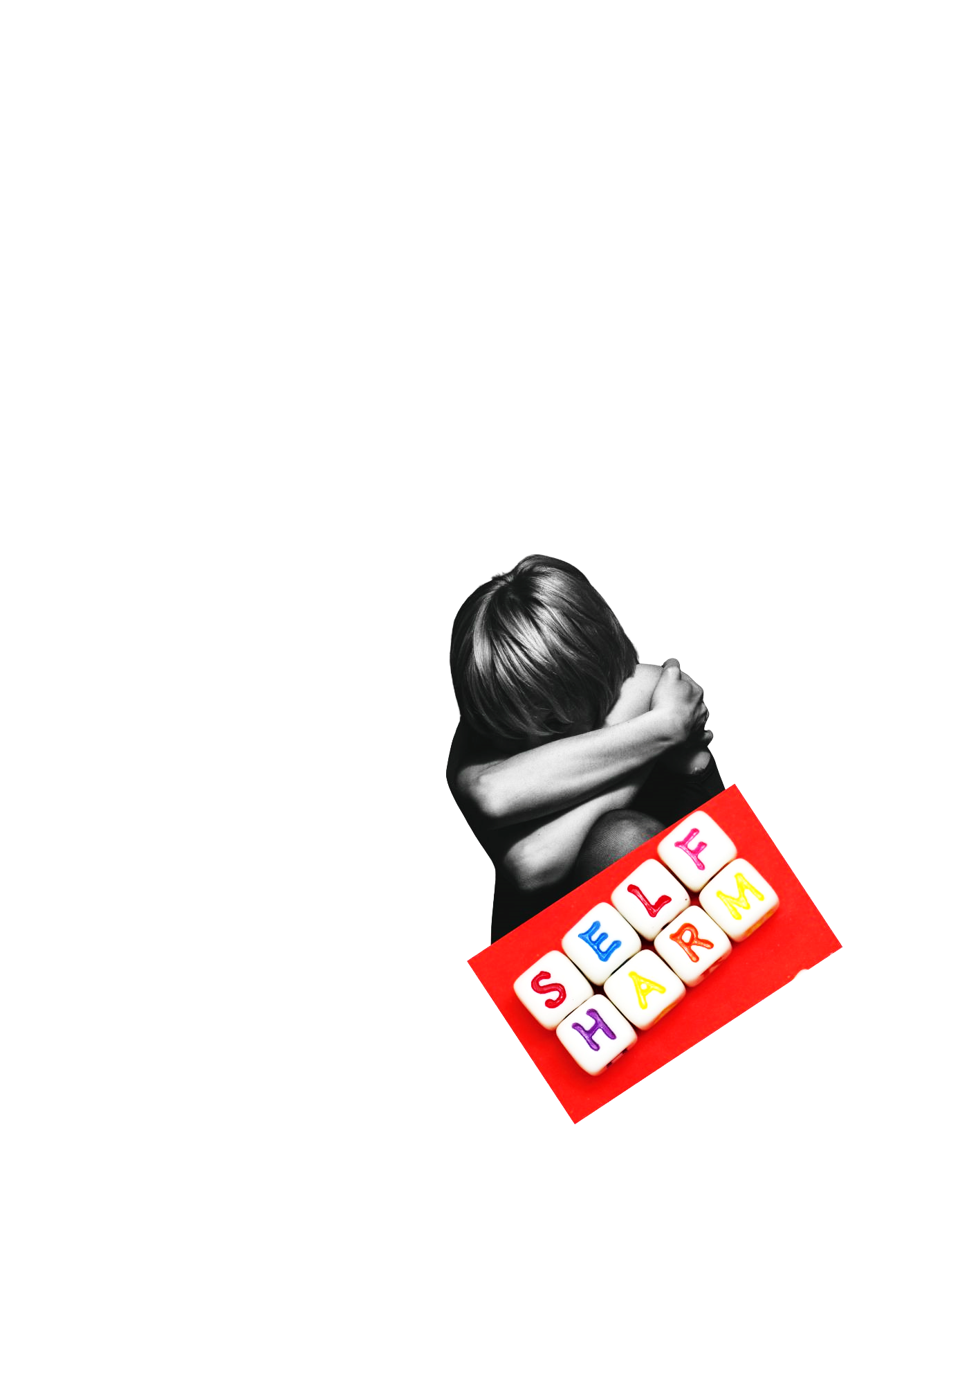 who have negative thoughts and emotions.

**What makes people harm themselves?**

Although everyone's experience is unique, the following are some of the causes:

* Difficulty to manage challenging emotions and thoughts.
* To communicate your state of being to others.
* To get others to pay attention.
* To seek attention.

Self-harm of any kind, like overdosing on medications, can be extremely harmful. You should speak with someone right away if you're feeling this way.

37



* It hurts.
* A cut or burn that becomes infected hurts a lot.
* Self-harm brings back memories of what you are attempting to escape.
* If you're heavily scarred, people will treat you differently.
* People you are close to find it upsetting.

Writing down your motivations for wanting to stop can be helpful.

38

**Why do people want to stop self-** **harming?**

There are several reasons for quitting self-harm:



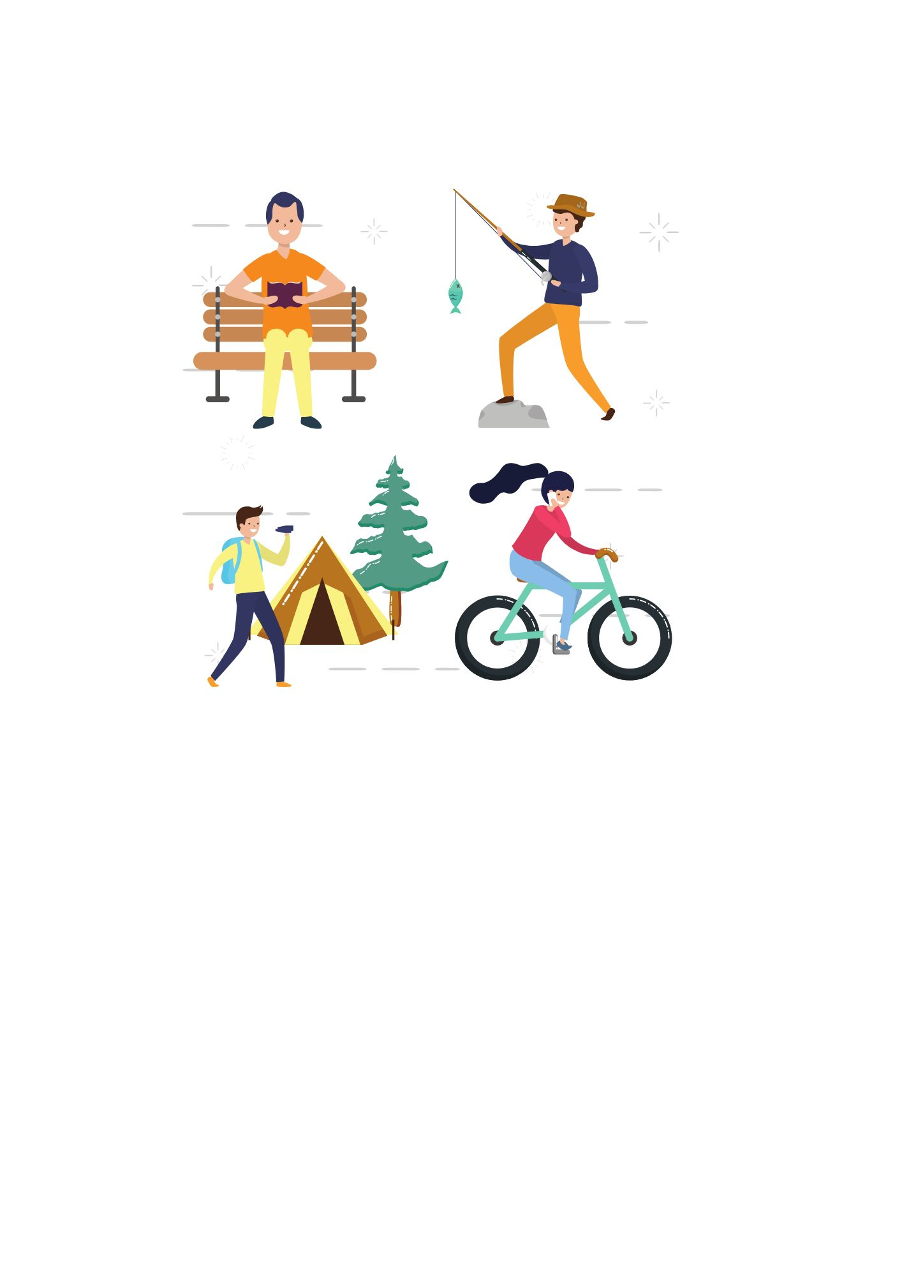

**Things that might help**

* Spend time with loved ones and close friends.
* Exercise, take a stroll.
* Divert your attention.
* Paint or draw.
* Treat yourself, go shopping.
* Try to unwind, read a book, or watch TV.
* Avoid using anything that could cause you harm.
* Discuss your feelings with a person.

39

**Bereavement**

Everybody experiences grief in a different way. Individuals respond differently to death. Although it is not simple, almost everyone encounters this at some point in their lives.

When a loved one passes away, most people are shocked for a few days.

Feelings you could experience in the initial days or weeks include:

* Sadness
* Anger
* Loneliness
* Fear
* Guilt
* Numbness
* Panic

Some people find that keeping themselves occupied with funeral arrangements or other tasks helps them get through a difficult time.

Some feel they need a lot of support and assistance because they are unable to cope at all.

These emotions are all normal.

40

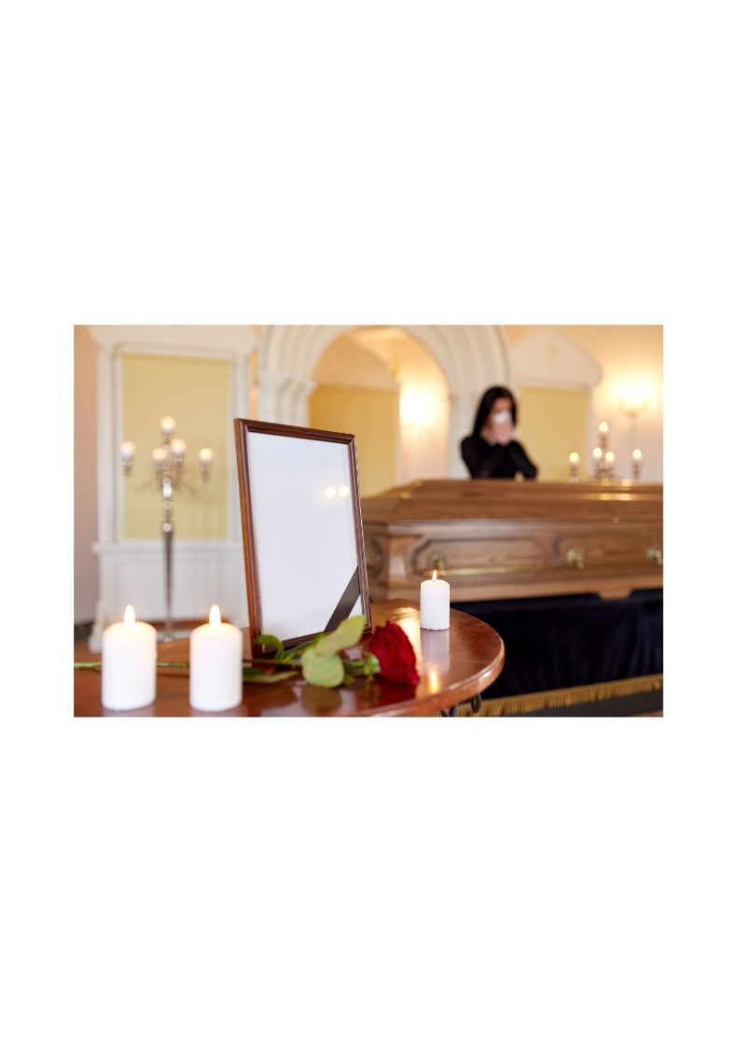

**After a few weeks or some time has passed.**

After a loved one passes away, it may take a while to feel better.

Some people have months-long anxiety. They could maintain a high level of activity, perhaps even cleaning the entire house.

People frequently experience guilt and question whether they could have helped more.

Anger can be directed either at the deceased or at those in their immediate vicinity.

All these emotions are normal, but you should talk to your doctor or another trusted person if you are concerned.



41

**When will I feel better?**

It might take a while to start feeling better.

Most people begin to feel like they can live happy lives and begin to think about the deceased person a little less. Usually, this takes a year or two.

Remember that "moving on" and finding happiness again does not imply that you have forgotten the deceased person but rather you have learnt to adapt to the grief and move forward in your life.

42



**How can I help myself?**

You may want to visit the deceased in the funeral home after they pass away. Some feel that this is helpful to them and wish to part ways. Others are unwilling to participate in this. What you do is up to you.

Get assistance from someone if you are arranging a funeral.

Funerals can be very expensive; try not to feel pressured to spend more than you can afford.

In the next weeks and months, taking care of yourself is crucial.

* Get some rest and eat healthy.
* Speak with others about your feelings.
* Speak with your doctor, or a therapist, or friends and family.
* Try to visit your loved ones.
* Try and make new friends, sign up for clubs and local groups.
* Make plans for special occasions like birthdays, anniversaries, or religious holidays.
* Aim to avoid making significant life changes, such as relocating or starting a new job. When they start to feel better, people frequently regret making these adjustments.
* Avoid using dangerous substances like alcohol, drugs, or smoking to cope or feel better.

43

43

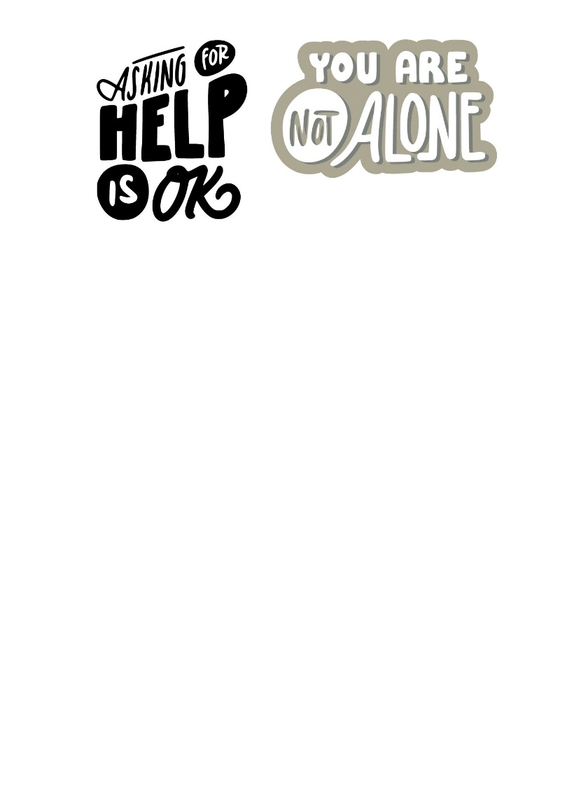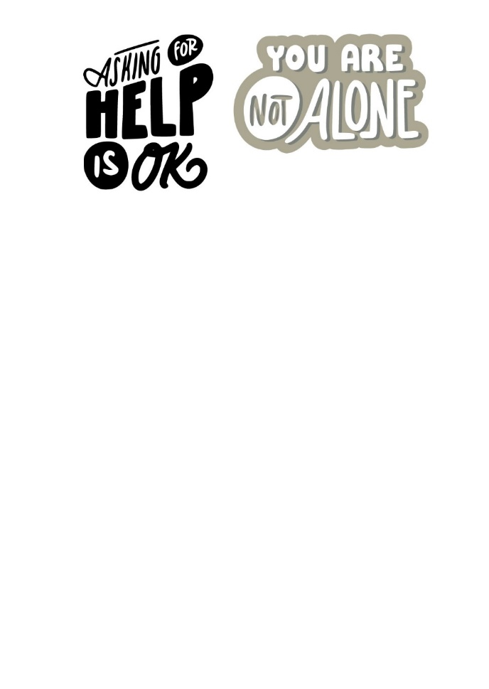

Where can you get more help?

At the front of this booklet there are contact information for various organisations that can help you through any mental health illness or bereavement.

It is important to know help is available and you don’t need to go through this alone.

Please speak to you GP or support worker if you feel you need help, and they will direct you to the right help.

Shama Women’s Centre offer Counselling services for both Men and women who may need therapeutic help in their journey.

**Please contact Shama Women’s centre on:**

**0116 251 47 47**

Sourced from:

<https://www.cntw.nhs.uk/home/accessible-information/easy-read/self-help-guides/>

<https://www.mind.org.uk/information-support/a-z-mental-health/>

New skills network - Mental health in adults

44