Support  We are here to help, not judge. We can  offer support with:  - Attitudes, Thinking & Behavior  - Accommodation  - Debts & Benefits  - Emotional Well-being  - Physical Health  - Education, Training & Employment  - Domestic Abuse  - Family & Children  - Drugs & Alcohol  If you have been offered an  appointment with the Women’s Pathfinder Caseworker make a note below.  Date:………………………………..  Time:………………………………  A caseworker will be in contact to confirm the location of the appointment.  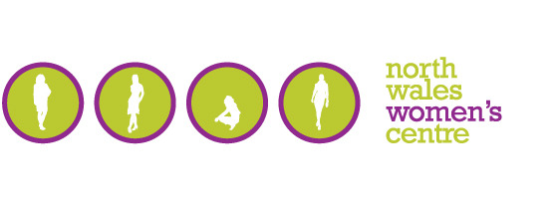    North Wales Women’s Centre  North Wales Women’s Centre is a local independent charity.  Our mission is to cultivate and advance the social and economic development of women in our community. That means we’re passionate about supporting, and enabling women to:  Develop aspirations.  Improve skills.  Build on their assets.  Take control of their lives  Move forward.  Overcome adversity.  Achieve their potential and thrive.  We work to ensure our services:  1. Meet the needs of women  2. Are accessible to all women  3. Make a difference in women's lives  About Womens Pathfinder  The pathfinder scheme aims to support any women with complex needs or are at risk of offending/re-offending.  The support you receive will be tailored to you and may include, one-to-one or possibly group work if appropriate to help you make lasting changes in order to build a positive life.  We have expanded.  Our dedicated team are now supporting women in all areas of North Wales, to include outreach work in Wrexham, Flintshire, Bangor, and Caernarfon.  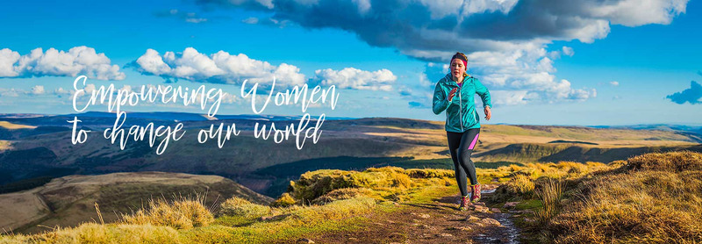  “The caseworker made me feel at ease, listened to what I had to say, didn’t judge me, offered me advice, which I took on board. I wasn’t sure if I would come back, but I’m glad I did! It made me get up, get out and actually speak about how I feel to someone who was willing to listen and help me.” | North Wales Women’s Centre  45-54 Water Street, Rhyl, LL18 1SS  Ty Pawb, Market Street, Wrexham, LL13 8BY.  Glanfa, Orme Road, Bangor, LL57 1AY  Email: pathfinder@northwaleswomenscentre.co.uk   |   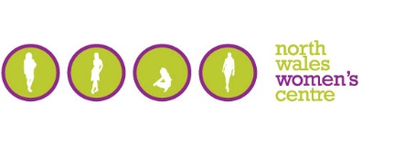  Women’s Pathfinder  Supporting women to make  Positive and lasting change  “The Centre has made me feel empowered and better able to cope with all the difficulties that have and are facing me. A very big thank you!”

