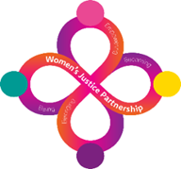

**WOMEN’S SERVICES**

**West Midlands**

**HMP Peterborough**

**Handbook for Women**

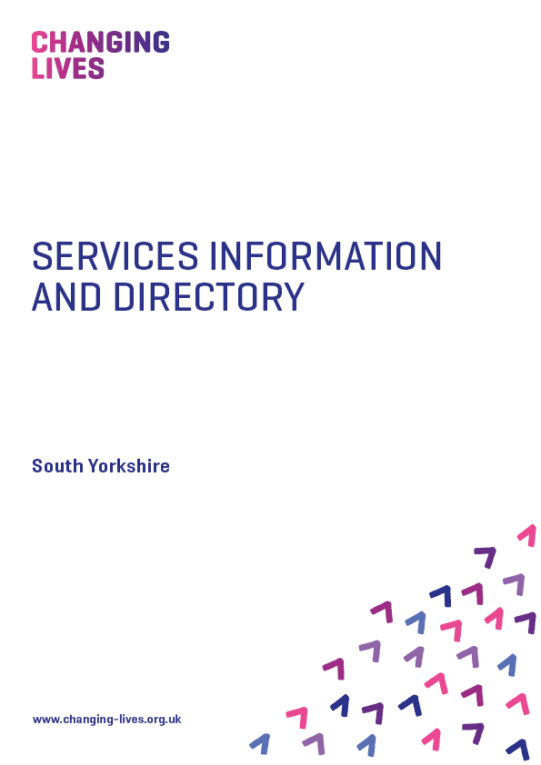

**Our Services in Custody**

**New Dawn New Day, Anawim, BCWA, Changing Lives and GSA work together** with the Probation Service to provide a dedicated Custody to Community process for women in Leicestershire, Warwickshire, West Midlands and Staffordshire.

**Criminal Justice Practitioner**

**Melissa Higgs**

M. 07812 668371

[melissa.higgs@changing-lives.org.uk](mailto:melissa.higgs@changing-lives.org.uk)

[melissa.higgs@changinglives.cjsm.net](mailto:melissa.higgs@changinglives.cjsm.net)

* Melissa is based at The Link

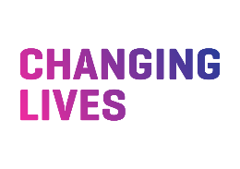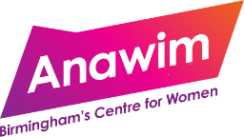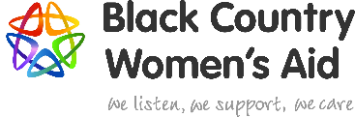

**Referral Process**

Referrals are to be made through the referral, monitor and intervention system. These can only be made by the Community Offender Manager.

Once the referral is received, we will arrange to complete the Change Point Assessment prior to the release date so that support can be offered.

Accommodation and Social Inclusion are the main pathways for a woman in custody, however additional pathways can be included on the initial referral and these pathways will be transferred to a community support worker upon release to ensure a smooth transition from custody to community.

**Referral Pathways for Custody**

|  |  |
| --- | --- |
| **Accommodation** | * Secure and sustain tenancies * Assistance with ROTL and HDC * Support with financial assistance (bank accounts, grant applications etc) * Tenancy Management course |
| **Social Inclusion** | * Mentoring – peer mentoring training and volunteer, support to improve relationships * Outreach - Prison in-reach support, meet at the gate or in the community on the day of release, accompany to release date appointments, and provide daily contact during first two weeks of release. |

**Our Services in the Community**

**What do we offer in the community?**

**Specialist Women’s Criminal Justice Practitioners** provide holistic support and deliver therapeutic interventions across all the pathways.

We use our **Change Point Assessment Tool** and work with Probation Practitioners to identify the areas of need and priorities.

Where appropriate we also use the **Do-it Profiler**, a resource to enable women with neurodiverse and/or learning needs to have their sensory needs profiled and strategies developed to support self-management.

Activities, interventions and workshops are delivered from our community-based hubs and centres. We provide outreach and wraparound support to women leaving custody identified as having social inclusion needs, as well as to women in the community who are unable/unsuitable to attend hub activities. Activities are delivered in small group or on a one-to-one basis.

Intensive support will be provided to women for the first two weeks following release from prison.

**Our Theory of Change – *Being, Becoming, Belonging*** – is a three-stage model of change which recognises that each stage is equally important to ensure sustained wellbeing and move-on from services. The stages of the model are:

**Being:** A person needs to make sense of their past, the trauma they may have experienced to be able to begin to contemplate the challenging process of change. A person needs to have hope that they can change their story and develop a different sense of self and identity.

**Becoming:** A person needs to have their basic needs met if they are to begin to make change, such as having somewhere safe and secure to live and enough funds to purchase basic essentials. They need access to services such as education and training to develop their resources/skills.

**Belonging:** People need to be welcomed by families, wider communities and employers if they are to sustain longer term desistance. They need access to opportunities to develop their strengths and aspirations if they are to belong and become fully contributing citizens.

***