|  |  |  |
| --- | --- | --- |
|  | |  |
|  |  | | |

**WOMEN’S SERVICES**

**Professionals’ Handbook for Warwickshire**

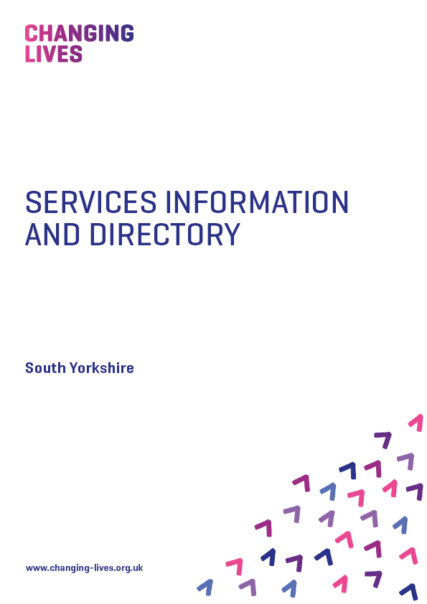

**Our Services**

**CONTENTS**

**Our Services 3**

**The Power of Positive Change 4-5**

**Referral Pathways 6-7**

**Guide to Workshops 8-11**

**Referral Process 12**

**Venues and Contacts 13-16**

**Our Services**

**Changing Lives** provides holistic inclusive services for women, by women. We deliver activities and bring local services to women from within their own communities.

**Specialist Outreach and Group Work Coaches** provide holistic support and deliver therapeutic interventions across all the pathways.

We use our **Change Point Assessment Tool** and work with Probation Practitioners to identify the areas of need and priorities. Where appropriate we also use the **Do-it Profiler**, a resource to enable women with neurodiverse and/or learning needs to have their sensory needs profiled and strategies developed to support self-management.

Activities, interventions and workshops are delivered from our community-based hubs and centres. We provide outreach and wraparound support to women leaving custody identified as having social inclusion needs, as well as to women in the community who are unable/unsuitable to attend hub activities. Activities are delivered in a group or one-to-one basis. Details of workshops can be found on page 7-10 of this guide.

Intensive support will be provided to women for the first 2 weeks following release from prison.

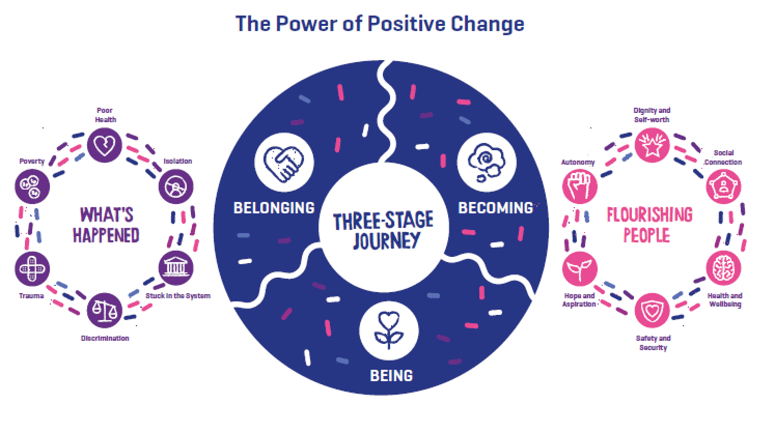

**Our Theory of Change – *Being, Becoming, Belonging*** – is a three-stage model of change which recognises that each stage is equally important to ensure sustained wellbeing and move-on from services. The stages of the model are:

**Being:** A person needs to make sense of their past, the trauma they may have experienced to be able to begin to contemplate the challenging process of change. A person needs to have hope that they can change their story and develop a different sense of self and identity.

**Becoming:** A person needs to have their basic needs met such as having somewhere safe and secure to live and enough funds to purchase the basic essentials if they are to begin to make change. They need access to services such as education and training to develop their resources/skills.

**Belonging:** People need to be welcomed by families, wider communities and employers if they are to sustain longer term desistance. They need access to opportunities to develop their strengths and aspirations if they are to belong and become fully contributing citizens.

**Referral Pathways**

|  |  |
| --- | --- |
| **AREA OF NEED** | **ACTIVITIES** |
| **ETE** | * Training and Employability courses * Literacy and Numeracy * Industry specific courses (through commissioned providers) * Job Clubs * Safeguarding existing employment   /training |
| **Accommodation** | * Secure and sustain tenancies * Duty to Refer applications * Assistance with ROTL and HDC * Support with financial assistance (bank accounts, grant applications etc.) * Tenancy Management course * Good Tenancy Portfolio |
| **Finance/Benefit/Debt** | * Assistance with benefits applications * Budgeting skills * Hosting Debt Advice sessions |
| **Dependency and Recovery** | * Alcohol brief advice and Extended alcohol brief advice * Stephanie Covington trauma informed programme Helping Women Recover   Gambling – brief intervention, triggers and relapse prevention   * Prepare for Treatment * Outreach support, referral and accompanying to commissioned services appointments * Mutual aid * Lived experience facilitated sessions |
| **Family and Significant Other** | * Risk assessment and Safety Planning, referral to local IDVA/ISVA service (high risk of harm) or domestic abuse service (low–medium risk of harm) * Referral to MARAC/Multi-Agency Safeguarding Hubs/Adult * Stephanie Covington Beyond Trauma programme * Outreach support to engage with specialist services, refer and accompany to appointments * Locally commissioned domestic abuse services to deliver awareness sessions * Referrals into existing supportive resources Saffron programme - co-produced with women in the CJS to address sex work, sexual exploitation and domestic abuse |
| **Lifestyle and Associates** | * Help develop community links, * support networks, pro-social attitudes, and understanding safeguarding, county lines, exploitation and radicalisation * Keeping Safe Online and Presenting yourself on Social Media * Respect, dealing with difficult situations in a respectful way * Future Steps - designed to support, educate and create a positive lifestyle * Making Good Programme – enable women to build on their sense of self-worth, develop pro-social skills through Volunteering and Peer Mentoring training. |
| **Emotional Wellbeing** | * Chrysalis **-** Gender responsive programme designed for women involved in the criminal justice system * Self-belief - Confidence Building, Motivation and Positive Thinking * Health and Wellbeing – Empowerment, Stress Management, Resilience * Referral/support to access to Counselling and Listening Ear |
| **Social Inclusion** | * Mentoring – peer mentoring training and volunteer, support to improve relationships * Outreach - Prison in-reach support, meet at the gate or in the community on day of release, accompany to day of release appointments, and provide daily contact during first two weeks of release. |

**Guide to our Workshops**

|  |  |
| --- | --- |
| **WORKSHOP** | **CONTENT** |
| **Acquiring and Managing your own Tenancy** | The workshop will explore the following topics.   * Applying for Housing * The Responsibilities of a Tenant * The Responsibilities of a Landlord * Non-Payment of Rent and Financial Support * Help with Claiming Benefits * Utility Bills and Home Furniture * Furnishings and Household Items * Your Income * Avoiding Debt * Types of Eviction * Ending Your Tenancy |
| **Budgeting** | **The Budgeting workshop will help to develop an understanding of personal budgeting. It aims to enable women to manage their own personal budget and explores the following topics:**   * What Is Budgeting? * Your Income * Your Essential Outgoings * Non-Essential Outgoings * Your Budget * Living Within Your Budget * Boosting Your Budget * What Is Debt * Other Problems That Debt May Cause * Acknowledging Your Debt * Prioritising Your Debts * Dealing With Your Debt |
| **Employability** | The Employability workshop will help to prepare women for the world of work and explores the following topics:   * Strengths and Skills * Identifying Own Strengths and Skills * Demonstrating Strengths and Skills * Boosting Your Employability Skills * Where are Jobs Advertised? * Keywords in Job Adverts * Job Applications Forms * Covering Letters * CV * Preparing for a Job Interview * Job Interview Questions |
| **Health and Wellbeing** | The aim of the Health and Wellbeing workshop is to help women develop an understanding of issues that could affect their health and wellbeing and explores the following topics:   * What is Physical Fitness * Benefits of Physical Fitness * Nutrition * The Importance of Healthy Eating * Food Hygiene * Consequences of Poor Food Hygiene * Personal Hygiene * What is Sexual Health * Consensual Sex * Contraception * Sexually Transmitted Infections * Preventing STI’s * The Effects of Drugs and Alcohol * The Health Risks of Smoking |
| **Mental Health** | The Mental Health workshop will help women to better understand what mental health is, how to access support around health issues and will give women an understanding of how emotions and well-being link to mental health. The workshop explores the following topics:   * What is Mental Health * Mental Illness * The Impact of Mental Illness * Poor Mental Health * Being Emotionally Healthy * Improve and Maintain Emotional Health * Emotional Resilience * 5 Steps to Mental Wellbeing * Advice and Support |
| **Self-Belief** | The Self-Belief workshop will help women to understand the impact of confidence and self-esteem and will support them to develop ways of building their own confidence and self-esteem. The workbook explores the following topics:   * Confidence * The Benefits of Being Confident * The Impact of Your Confidence on Others * Other People’s Perception of Low Confidence * Self-Esteem * Factors That Affect Self-Esteem * Building Confidence and Self Esteem * Your Strengths and Self-Worth * Using Confidence Building Strategies * Being Assertive * Practicing Assertiveness * Learning To Say No |
| **Volunteering and Peer Mentoring** | The Volunteering and Peer Mentoring workshop will cover both topics by exploring the following:   * Voluntary Organisations * Roles of Volunteers in an Organisation * Identifying Current Voluntary Roles * Searching and Applying for Vacancies * Understanding Peer Mentoring * Establishing Peer Mentoring Relationship * Setting Boundaries * Confidentiality * Safeguarding * Reporting Concerns * Personal Safety * Making Referrals |
| **Chrysalis** | This is a gender responsive programme that will build upon women’s strengths to increase self-confidence. We use a combination of modules:  • Personal Attributes & Achievements &  Self-Limiting Belief  • Confidence and Self-Esteem  • Assertiveness, Opinions, Bias and Facts  • Stress, Anger Management, Negative  and Positive Thought Chains |
| **Saffron** | Co-produced with women in the Criminal Justice System to address sex work, sexual exploitation and domestic abuse. Modules cover:  • Emotional Resilience  • Healthy Relationships  • Sexual Health and Wellbeing –  specifically to support women involved in  the sex industry  • Positive Parenting – supporting women  where child concern issues are identified. |
| **Stephanie Covington Programme** | **Beyond Trauma for Women** – programme to help women recover from the effects of trauma. Sessions will be individually tailored using a combination of modules.  Modules include:   * Violence, Abuse & Trauma * The impact of trauma on women’s lives * Healing from trauma   **Helping Women Recover** – supporting women with addictions using all/combination of modules   * Self * Defining Self * Sense of Self * Self Esteem * Sexism, Racism, and Stigma * Relationships * Family of Origin * Mothers * Mother Myths * Interpersonal Violence * Creating Healthy Relationships and Support Systems * Sexuality * Sexuality and Addiction |

**Referral Process**

Referrals to be made through the refer and monitor an intervention system. Once the referral is received, we will arrange to complete the Change Point Assessment at the hub or at a community setting if not appropriate.

Please only make referrals if the service user is ready to participate and engage, as this will allow for the women to receive the best from the service.

**Venue Locations**

**GSA Warwickshire – Where we are**

**Hope 4, The Hope Centre,   
8 Newbold Road, Rugby, CV21 2LJ**

**Dale Street Church, Dale Street,   
Royal Leamington Spa, CV32 5HL**

**St Nicolas Church, 12 Vicarage St, Nuneaton CV11 4AZ**

**GSA Warwickshire – Contact Details**

**Interventions Manager**

Sarah Marsden

M: 07980 586583

[sarah.marsdenl@changing-lives.org.uk](mailto:sarah.marsdenl@changing-lives.org.uk)

[sarah.marsden@changinglives.cjsm.net](mailto:sarah.marsden@changinglives.cjsm.net)

**Senior Specialist Women’s Criminal Justice Practitioner**

Charlotte Liddell

M: 07706 349150

[charlotte.liddell@changing-lives.org.uk](mailto:charlotte.liddell@changing-lives.org.uk)

[charlotte.liddell@changinglives.cjsm.net](mailto:charlotte.liddell@changinglives.cjsm.net)

**Specialist Women’s Justice Practitioners**

Sarah McSweeney

M: 07471 355301

[sarah.mcsweeney@changing-lives.org.uk](mailto:sarah.mcsweeney@changing-lives.org.uk)

sarah.mcsweeney@changinglives.c.jsm.net

Charlotte Turner

M. 07706 349605

[charlotte.turner@changing-lives.org.uk](mailto:charlotte.turner@changing-lives.org.uk)

[charlotte.turner@changinglives.cjsm.net](mailto:charlotte.turner@changinglives.cjsm.net)

Jemmanai Orgill-Howell

M: 07706 310146

[ruth.skillern@changing-lives.org.uk](mailto:ruth.skillern@changing-lives.org.uk)

[ruth.skillern@changinglives.cjsm.net](mailto:ruth.skillern@changinglives.cjsm.net)

Debbie Collins

M: 07706 310148

[debbie.collins@changing-lives.org.uk](mailto:debbie.collins@changing-lives.org.uk)

[debbie.collins@changinglives.cjsm.net](mailto:debbie.collins@changinglives.cjsm.net)

Stephanie Saterlay

M: 07706 335177

[stephanie.saterlay@changing-lives.org.uk](mailto:stephanie.saterlay@changing-lives.org.uk)

[stephanie.saterlay@changinglives.cjsm.net](mailto:stephanie.saterlay@changinglives.cjsm.net)

**Custody Coordinator**

Ruth Skillern

M. 07706 349147

[ruth.skillern@changing-lives.org.uk](mailto:ruth.skillern@changing-lives.org.uk)

[ruth.skillern@changinglives.cjsm.net](mailto:ruth.skillern@changing-lives.cjsm.net)

