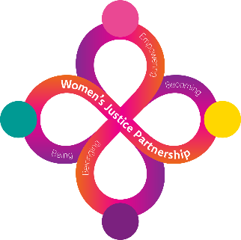

**WOMEN’S SERVICES**

**West Midlands**

**Handbook for Participants**

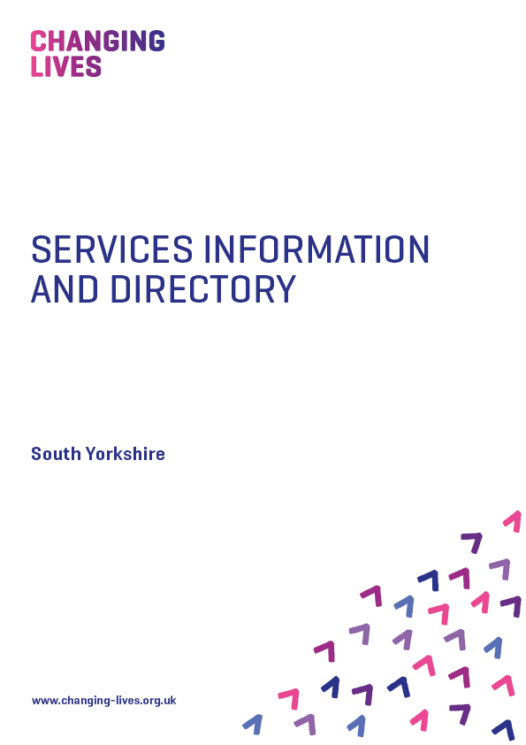

**CONTENTS**

**Who we are/What we do 3**

**The Workshops 4-7**

**Next Steps 8**

**Expectations 8**

**Your progress 9**

**What you really need to know 10**

**Comments and Complaints 10**

**Where we are and Contacts 11-19**

**Who we are/What we do**

**Changing Lives** provide support to women with experience of the criminal justice system in the West Midlands. We provide services in an inclusive female only environment which support women to raise their self-esteem and aspirations by offering opportunities to make informed choices.

This project is just one part of a range of exciting and relevant services that we deliver. We hope that you will find our services useful and inspiring in supporting you to achieve your potential.

In this leaflet, you will find more information about how we work with your Probation Practitioners.

We offer a combination of group sessions and one to one support, tailored to meet women’s needs.

The main aim is to assist women to establish a healthy, positive lifestyle by building on their strengths to achieve their goals.

We deliver a range of workshops, see pages 4-7.

We can also support you with Education, Training and Employment and applying for or maintaining accommodation. We work closely with other agencies who offer support with parenting, drugs and alcohol and much more. Your Specialist Women’s worker can help you access these services.

**The Workshops**

|  |  |
| --- | --- |
| **WORKSHOP** | **CONTENT** |
| **Acquiring and Managing your own Tenancy** | The workshop will explore the following topics:   * Applying for Housing * The Responsibilities of a Tenant * The Responsibilities of a Landlord * Non-Payment of Rent and Financial Support * Help with Claiming Benefits * Utility Bills and Home Furniture * Furnishings and Household Items * Your Income * Avoiding Debt * Types of Eviction * Ending Your Tenancy |
| **Budgeting** | **The Budgeting workshop will help to develop an understanding of personal budgeting. It aims to enable women to manage their own personal budget and explores the following topics:**   * What Is Budgeting? * Your Income * Your Essential Outgoings * Non-Essential Outgoings * Your Budget * Living Within Your Budget * Boosting Your Budget * What Is Debt * Other Problems That Debt May Cause * Acknowledging Your Debt * Prioritising Your Debts * Dealing With Your Debt |
| **Employability** | The Employability workshop will help to prepare women for the world of work and explores the following topics:   * Strengths and Skills * Identifying Own Strengths and Skills * Demonstrating Strengths and Skills * Boosting Your Employability Skills * Where are Jobs Advertised? * Keywords in Job Adverts * Job Applications Forms * Covering Letters * CV * Preparing for a Job Interview * Job Interview Questions |
| **Health and Wellbeing** | The aim of the Health and Wellbeing workshop is to help women develop an understanding of issues that could affect their health and wellbeing and explores the following topics:   * What is Physical Fitness * Benefits of Physical Fitness * Nutrition * The Importance of Healthy Eating * Food Hygiene * Consequences of Poor Food Hygiene * Personal Hygiene * What is Sexual Health * Consensual Sex * Contraception * Sexually Transmitted Infections * Preventing STI’s * The Effects of Drugs and Alcohol * The Health Risks of Smoking |
| **Mental Health** | The Mental Health workshop will help women to better understand what mental health is, how to access support around health issues and will give women an understanding of how emotions and well-being link to mental health. The workshop explores the following topics:   * What is Mental Health * Mental Illness * The Impact of Mental Illness * Poor Mental Health * Being Emotionally Healthy * Improve and Maintain Emotional Health * Emotional Resilience * 5 Steps to Mental Wellbeing * Advice and Support |
| **Self-Belief** | The Self-Belief workshop will help women to understand the impact of confidence and self-esteem and will support them to develop ways of building their own confidence and self-esteem. The workbook explores the following topics:   * Confidence * The Benefits of Being Confident * The Impact of Your Confidence on Others * Other People’s Perception of Low Confidence * Self-Esteem * Factors That Affect Self-Esteem * Building Confidence and Self Esteem * Your Strengths and Self-Worth * Using Confidence Building Strategies * Being Assertive * Practicing Assertiveness * Learning To Say No |
| **Volunteering and Peer Mentoring** | The Volunteering and Peer Mentoring workshop will cover both topics by exploring the following:   * Voluntary Organisations * Roles of Volunteers in an Organisation * Identifying Current Voluntary Roles * Searching and Applying for Vacancies * Understanding Peer Mentoring * Establishing Peer Mentoring Relationship * Setting Boundaries * Confidentiality * Safeguarding * Reporting Concerns * Personal Safety * Making Referrals |
| **Chrysalis** | This is a gender responsive programme that will build upon women’s strengths to increase self-confidence. We use a combination of modules:  • Personal Attributes & Achievements &  Self-Limiting Belief  • Confidence and Self-Esteem  • Assertiveness, Opinions, Bias and Facts  • Stress, Anger Management, Negative  and Positive Thought Chains |
| **Saffron** | Co-produced with women in the Criminal Justice System to address sex work, sexual exploitation and domestic abuse. Modules cover:  • Emotional Resilience  • Healthy Relationships  • Sexual Health and Wellbeing –  specifically to support women involved in  the sex industry  • Positive Parenting – supporting women  where child concern issues are identified. |
| **Stephanie Covington Programme** | **Beyond Trauma for Women** – programme to help women recover from the effects of trauma. Sessions will be individually tailored using a combination of modules.  Modules include:   * Violence, Abuse & Trauma * The impact of trauma on women’s lives * Healing from trauma   **Helping Women Recover** – supporting women with addictions using all/combination of modules   * Self * Defining Self * Sense of Self * Self Esteem * Sexism, Racism, and Stigma * Relationships * Family of Origin * Mothers * Mother Myths * Interpersonal Violence * Creating Healthy Relationships and Support Systems * Sexuality * Sexuality and Addiction |

**Next Steps**

At the end of each session, we will review your progress together, your worker can also talk to you about what other services are available. She will also be able to refer you to any other agencies to support and help you with your next steps.

**Expectations**

**What can you expect?**

* We will meet with you and your Probation Practitioner to agree a plan at the start of working together with you and again for reviews as required.
* All women will be treated with respect, empathy, dignity and will not be discriminated against or disadvantaged because of any characteristics.
* A friendly, supportive and flexible approach in meeting your needs.
* Our staff are required to share information with your Probation Practitioner in relation to your progress, attendance and outcomes.

* Sharing information with other agencies or third parties will only happen with your written consent, unless we are concerned about your wellbeing or there is a potential risk to others. In this case staff will follow the Data Protection and Confidentiality Policies.

**What we ask from you**

* Please attend the sessions on time.
* Please let us know if you are unable to attend your appointment and the reason why.
* Please let us know if you are experiencing any problems in completing any of the workshops because we might be able to help!
* Please do not attend groups under the influence of drugs or alcohol. Other people may be working hard to stay free from drink and drugs and we will have to ask you to leave.
* Please do not behave in such a way to cause any offence to others.
* Please provide us with up-to-date contact details.

**Your Progress**

Your journey will be supported via a joint assessment and review with you and your Probation Practitioner. This helps you to evidence what you have achieved as well as giving you the chance to explore and identify your next steps.

**What you really need to know**

It is important that you are aware that appointments made with us are compulsory:

Your Probation Practitioner will be advised on the day of any non-attendance. They may then write to you to find out why you have not attended. This is called the enforcement process.

Although we will confirm any contact you have had with us, it is important that you know the decision about enforcement is made by your Probation Practitioner. If you do miss an appointment for whatever reason, we encourage you to contact us and come in as soon as possible, so that we can let your Probation Practitioner know you have been in touch.

**Comments and Complaints**

We have a comments and complaints leaflet which can be found in the waiting area. We welcome and value your comments. Complaints, praise and/or ideas, which will help us to improve our service, or simply let us know when we are getting it right or wrong. You can complete this without saying who you are but if you do want a reply, please let us have your name and contact details. If you do require a response, then you can expect an answer within 28 days.

If you have any questions or queries about your journey with us, please do not hesitate to contact us on the telephone numbers provided.

**Where we are**

**Anawim**

**Birmingham - Where we are**

228 Mary St, Balsall Heath, Birmingham B12 9RJ (01302) 309822

Website: www.anawim.co.uk



**Birmingham**

**Anawim - Contact Details**

**Criminal Justice Manager**

Rachael Harris

M: 07496 184858

[rachael.harris@changing-lives.org.uk](mailto:rachael.harris@changing-lives.org.uk)

[rachael.harris@changinglives.cjsm.net](mailto:rachael.harris@changinglives.cjsm.net)

**Specialist Women’s Criminal Justice Practitioners**

Parminder Kaur

M: 07706 349155

[Parminder.kaur@changing-lives.org.uk](mailto:Parminder.kaur@changing-lives.org.uk)

[parminder.kaur@changinglives.cjsm.net](mailto:parminder.kaur@changinglives.cjsm.net)

Priya Hayre

M: 07812 663051

[priya.hayre@changing-lives.org.uk](mailto:priya.hayre@changing-lives.org.uk)

[priya.hayre@changinglives.cjsm.net](mailto:priya.hayre@changinglives.cjsm.net)

Grace Bignell

M: 07706 349189

[grace.bignell@changing-lives.org.uk](mailto:grace.bignell@changing-lives.org.uk)

[grace.bignell@changinglives.cjsm.net](mailto:grace.bignell@changinglives.cjsm.net)

Vacancy

M: 07706 349187

[@changing-lives.org.uk](mailto:lorna.pyne@changing-lives.org.uk)

[@changinglives.cjsm.net](mailto:lorna.pyne@changing-lives.cjsm.net)

**Sandwell & Dudley, Birmingham**

**BCWA - Where we are**

The Cedar Centre Birmingham

4 Boxworks, Carver Street, Birmingham, B1 3AP

**2nd Floor Landchard House, Victoria Street, West Bromwich, B70 8HY**

(0121) 553 0090

**Website: www.blackcountrywomensaid.co.uk**

**Black Country Women’s Aid**

**Contact Details**

**Service Manager**

Amy Colbourne

M: 07706 349175

[amy.colbourne@changing-lives.org.uk](mailto:FrancescaF@togetherwomen.org)

amy.colbourne@changinglives.cjsm.net

​

**Specialist Women’s Justice Practitioners**

Megan Price

M: 07706 349 181

[Megan.price@changing-lives.org.uk](mailto:Megan.price@changing-lives.org.uk)

Megan.price@changinglives.cjsm.net

Catarina Santos

M: 07706 349184

[catarina.santos@changing-lives.org.uk](mailto:GeorginaD@togetherwomen.org)

catarina.santos@changinglives.cjsm.net

Jane Turley

M. 07706 349182

[jane.turley@changing-lives.org.uk](mailto:jane.turley@changing-lives.org.uk)

jane.turley@changinglives.cjsm.net

Shannon McDonnell

M. 07706 349178

[shannon.mcdonnell@changing-lives.org.uk](mailto:shannon.mcdonnell@changing-lives.org.uk)

shannon.mcdonnell@changinglives.cjsm.net

Hollie Edwards

M: 07775 964 105

[hollie.edwards@changing-lives.org.uk](mailto:hollie.edwards@changing-lives.org.uk)

[hollie.edwards@sandwellwa.cjsm.net](mailto:hollie.edwards@changing-lives.cjsm.net)

Helen Smith

M: 07706 349190

[salome.bakongo@changing-lives.org.uk](mailto:salome.bakongo@changing-lives.org.uk)

salome.bakongo@changinglives.cjsm.net

**Wolverhampton**

**Changing Lives – Where we are**

Unit 18 & 19 Chubb Building, Fryer Street, Wolverhampton

(01902) 341822

**Changing Lives - Contact Details**

**Service Manager**

Nicola Salt

M: 07812 663504

[nicola.salt@changing-lives.org.uk](mailto:nicola.salt@changing-lives.org.uk)

Nicola.salt@changing-lives.cjsm.net

​

**Specialist Women’s Justice Practitioners**

Lakhbir Kaur

M: 07812 663069

[lakhbir.kaur@changing-lives.org.uk](mailto:lakhbir.kaur@changing-lives.org.uk)

[Lakhbir.kaur@changinglives.cjsm.net](mailto:Lakhbir.kaur@changinglives.cjsm.net)

Josie Webb

M: 07814 218577

[josie.webb@changing-lives.org.uk](mailto:josie.webb@changing-lives.org.uk)

[josie.webb@changinglives.cjsm.net](mailto:josie.webb@changinglives.cjsm.net)

Sam Lockley

M. 07812 665134

[sam.lockley@changing-lives.org.uk](mailto:sam.lockley@changing-lives.org.uk)

[sam.lockley@changinglives.cjsm.net](mailto:sam.lockley@changinglives.cjsm.net)

Alix Eccles

M: 07912 281010

[alix.eccles@changing-lives.org.uk](mailto:alix.eccles@changing-lives.org.uk)

[alix.eccles@changinglives.cjsm.net](mailto:alix.eccles@changinglives.cjsm.net)

**Custody Coordinator**

Ruth Skillern

M. 07706 349147

[ruth.skillern@changing-lives.org.uk](mailto:ruth.skillern@changing-lives.org.uk)

[ruth.skillern@changinglives.cjsm.net](mailto:ruth.skillern@changinglives.cjsm.net)

**Coventry**

**GSA – Where we are**

Koco Community Resource Centre; 15 The Arches; Spon End; Coventry; CV1 3JQ

(02476) 714 988

**Website:** [www.greensquaregroup.com](http://www.greensquaregroup.com)

**Three Trees Community Centre, Hedingham Grove**

**Birmingham, B37 7TP**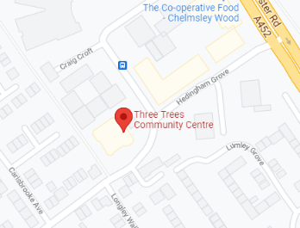

**Coventy & Solihull – Contact Details**

**Interventions Manager**

Sarah Marsden

M: 07980 586583

[sarah.marsdenl@changing-lives.org.uk](mailto:sarah.marsdenl@changing-lives.org.uk)

[sarah.marsden@changing-lives.cjsm.net](mailto:sarah.marsden@changing-lives.cjsm.net)

**Senior Specialist Women’s Criminal Justice Practitioner**

Charlotte Liddell

M: 07706 349150

[charlotte.liddell@changing-lives.org.uk](mailto:charlotte.liddell@changing-lives.org.uk)

[charlotte.liddell@changing-lives.cjsm.net](mailto:charlotte.liddell@changing-lives.cjsm.net)

**Specialist Women’s Justice Practitioners**

Susan Horner

M: 07706 349138

[susan.horner@changing-lives.org.uk](mailto:susan.horner@changing-lives.org.uk)

[susan.horner@changing-lives.cjsm.net](mailto:susan.horner@changing-lives.cjsm.net)

Jemmanai Orgill-Howell

M: 07706 310146

[ruth.skillern@changing-lives.org.uk](mailto:ruth.skillern@changing-lives.org.uk)

[ruth.skillern@changing-lives.cjsm.net](mailto:ruth.skillern@changing-lives.cjsm.net)

Debbie Collins

M: 07706 310148

[debbie.collins@changing-lives.org.uk](mailto:debbie.collins@changing-lives.org.uk)

[debbie.collins@changing-lives.cjsm.net](mailto:debbie.collins@changing-lives.cjsm.net)

Stephanie Saterlay

M: 07706 335177

[stephanie.saterlay@changing-lives.org.uk](mailto:stephanie.saterlay@changing-lives.org.uk)

[stephanie.saterlay@changing-lives.cjsm.net](mailto:stephanie.saterlay@changing-lives.cjsm.net)

|  |  |
| --- | --- |
|  |  |

